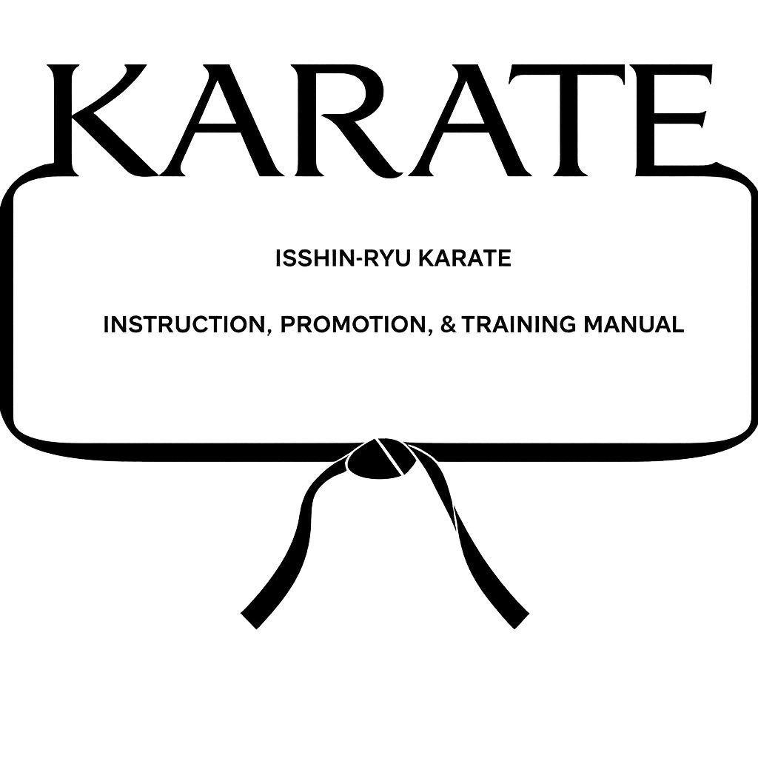

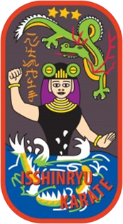

TABLE OF CONTENTS
Welcome.....................................................................1
Rules of the Dojo...........................................................2
Formal Procedures of the Dojo...............................................3
Required Reading List.......................................................4
Why Study Karate............................................................5
What is Karate..............................................................6
Tatsuo Shimabuku............................................................7
Stephen Armstrong...........................................................9
The True Meaning of the Isshin-ryū Emblem..................................10
Requirement for Promotion to Yellow Belt...................................12
Features of Isshin-ryū Karate..............................................13
Code of Karate – Creed of Karate...........................................14
Code of Karate – Interpretations...........................................15
The History and Origin of Karate...........................................18
Important Events in Karate.................................................19
Karate Vocabulary..........................................................21
Counting...................................................................21
Rank System................................................................21
Area of Striking Techniques................................................22
Vital Points of the Body...................................................23
Pressure Points............................................................24
Karate Workout.............................................................27
Warm-up....................................................................29
Procedures on Making the Proper Isshin-ryū Fist............................30
Stretching.................................................................31
Basic Fundamental in Karate Techniques.....................................35
Breathing..................................................................39
Kiai.......................................................................41
Kata.......................................................................42
Kumite – Practice Fighting.................................................52
Requirements for Promotion to Green Belt...................................58
Respect for Sensei.........................................................59
The Martial Arts...........................................................60
Stances in Isshin-ryū Karate...............................................64
Makiwara...................................................................67
The Golden Rules of Karate.................................................68
Requirements for Promotion to Purple Belt..................................70
Ki – The Mysterios Energy..................................................71
Meditation.................................................................73
Mind Clearing Exercises....................................................75
The Growth Pyramid.........................................................76
Requirements for Promotion to 3rd Degree Brown Belt........................78
Rope Jumping...............................................................79
Proverbs...................................................................80
TABLE OF CONTENTS – CONTINUED
Requirements for Promotion to 2nd Degree Brown Belt........................82
Standard First Aid.........................................................83
Requirements for Promotion to 1st Degree Brown Belt........................94
Common Injuries............................................................95
Requirements for Promotion to Sho Dan......................................98
Appendix A: Student Creed..................................................99
Appendix B: Isshin-ryū Karate-Do & Self-Defense Dojo Patch................100
Appendix C: The 15 Principles.............................................101
Appendix D: Promotion Reports.............................................102
Appendix E: Promotion Kata Requirements...................................103
Appendix F: Isshin-ryū Kata Focuses.......................................104
Appendix G: Isshin-ryū Kata Lineage.......................................105
Uke Kata.................................................................105
Seisan Kata..............................................................106
Seiuchin Kata............................................................107
Dachi Kata...............................................................108
Naihanchi Kata...........................................................109
Wansu Kata...............................................................110
Chinto Kata..............................................................111
Kusanku Kata.............................................................112
Sunsu Kata...............................................................113
Sanchin Kata.............................................................114
Batta Wakai No Bo Kata...................................................115
Tokumine no Kun Kata.....................................................116
Urashi no Kun Kata.......................................................117
Shishi no Kun Kata.......................................................118
Kyan no Sai Kata.........................................................119
Kusanku Sai Kata.........................................................120
Chatan Yara no Sai Kata..................................................121
Hamahiga no Tuifa Kata...................................................122

Welcome
Welcome to the Karate training at the Orange City Isshin-ryū Karate and Self-Defense.
This booklet is the standard text for all students training at the true art of Isshin-ryū Karate. We will try and explain many of the things that will happen during the next few months of your training.
“No-One” just becomes a karateka, it takes a lot of hard work on your part. Time, effort, sweat, minor aches and pains, and the persistence that comes with striving for a certain goal is the only way one achieves its goal, regardless of the subject. Hard work and discipline is the only way your goal may be reached.
In the Karate dojo one is practicing all the time. Karate techniques and reflexes remain sharp at all times in an event of an attack. Everything you do is in self-defense. You start out with basic techniques which develops the foundation for more advanced techniques. All students perform the basics – beginners and advanced.
The instructor from time to time will be too hard, sometimes too easy, but always with one thing in mind, for you to become a good karateka.
This booklet has been designed to help you in achieving your goal.
WHITE - YELLOW – ORANGE – BLUE – GREEN – PURPLE – BROWN – BLACK BELT
“WELCOME TO KARATE”

RULES OF THE DOJO
- The Gi must be clean at all times.
- Fingernails and toenails must be trimmed and cleaned. Personal cleanliness and hygiene is most important.

- Smoking is prohibited in the dojo.
- Chewing gum is prohibited in the dojo.
- Students may not wear rings or other jewelry during practice.
- If you have any physical disability or restrictions, inform the instructor before class begins.
- Profanity is not allowed on or around the dojo.
- No drinking or eating is allowed on the dojo floor.
- Never leave clothing or valuables of any type in the dojo. We will not be responsible for these articles being lost or stolen.
- All members SHALL REMOVE their shoes before walking on the dojo
floor.
- Do not misuse any equipment in the dojo.
- No male student is allowed to spar without a protective cup. All
students must have a mouth guard before they begin to spar.
- Derogatory remarks about the instructors or fellow students will not
be tolerated.
- If a student withdraws from the dojo temporarily or permanently, let
the Sensei know immediately in person or by phone.
- No students are allowed to spar without the consent of the
instructor.

FORMAL PROCEDURES OF THE DOJO
- As you enter the dojo, a respectable bow is to be given to show your spirit and readiness to train.
- When entering the dojo, say either “Konnichi-Wa” (good day) or “Komban-Wa” (good evening on meeting) Sensei. When leaving, either “Sayonara” (good-bye), “Konnichi-Wa” or “O-Yasumi Nasai” (good night upon parting) Sensei.
- All students must sign their names in the attendance book.
- A Respectful bow is to be given whenever going on or off the dojo floor.
- If you walk into class late, stand at attention until the instructor has acknowledged your presence by bowing to you.
- When a Black Belt enters the dojo floor for the first time, the first student who sees him/her is to yell “OSH” (stop) and every student on the floor at that time is to stand at attention and bow to the Black Belt.
- All Black Belt instructors are to be addressed by their surname, e.g. Mr.__________ , Ms./Mrs.__________ .
- All students must keep steady attendance of no less than two classes per week.
- A student cannot leave class early without the permission of the instructor.
- Whenever an instructor is explaining or demonstrating a technique
all students must immediately stand at attention.
- Students are responsible for the techniques and forms they are
taught. At any time you may be asked to perform them. You learn by
SEEING, LISTENING, QUESTIONING & DOING.
- Absolutely no disrespect will be shown to any instructors or fellow
students.
- It is up to everyone to help keep the dojo clean. Inquire from time
to time to see if any help is needed in cleaning of the dojo, etc.
- At the start of your workout always turn and face the shrine and
bow. It is also customary to bow in the same manner before retiring
from the dojo floor.

- Always respect your Sensei and pay close attention to what he has to
say at all times. Each student should bow to the Sensei before and
after each class. Remember that true Karate begins and ends with
courtesy.
- Never laugh or joke during classes, as this is a serious time. You
should be thinking of improving your ability in Karate.

REQUIRED READING LIST

Promotion To Title Author
Yellow Belt "Isshin-ryū Karate" Steve Armstrong
Orange Belt "The Weaponless Warriors" Richard Kim
Blue Belt "The Karate Dojo" Peter Urban
Green Belt "Karate-Do--My Way of Life" Gichen Funakoshi
Purple Belt "History and Philosophy Michael J. Dobyns of Isshin-ryū Karate-do"
Third Brown "Okinawa--Island of Karate" George W. Alexander
Second Brown "Zen in the Martial Arts" Joe Hyams
First Brown "The Book of Five Rings" Miyamoto Musashi
Shodan "Living the Martial Way" Forest E. Morgan

WHY STUDY KARATE?
Self-defense is usually the reason why most students study Karate. One might call Karate an educated way of street fighting, but as you study Karate you’ll find that there is much more to it than this.
Whatever the new student’s reasons for studying Karate, he soon becomes aware of many benefits from his training, both expected and unexpected.
Karate, as a martial art, was perfected in Okinawa after many centuries in the Orient, is based upon both mental and bodily discipline. It is considered to be one of the finest forms of exercise.
With these qualities of conditioning, self-defense, the sporting aspect of Karate, the self confidence, the security and that Karate can become the ultimate perfection of the human character.
The karateka feels healthy and physically fit. He is confident that he is learning to defend himself and this quiet confidence filters through to all the phases of his daily life. The further he progresses in Karate, the greater the respect for himself, as well as for others.

WHAT IS KARATE
Karate is an ancient oriental art of self-defense which has been practiced for centuries.
The Japanese word “Karate” means empty hands, which implies that weapons are not used. However, weapons are used, but these are the natural weapons of the body – fists, openhands, elbows, feet and knees. Through this lightning-fast blocks, punches, chops, elbow strikes, kicks, the karateka is capable of defending themselves against one or more attackers.
Karate is a philosophy that goes beyond the boundaries of the obvious self-defense techniques. Within Karate is the potential of a new person, one whose real strength in the awareness and perception developed by mind-body discipline. Karate allows the whole body and mental energy to be directed in a single appointed way. This enables the practitioner to accomplish feats which amaze the uninitiated, but are viewed as commonplace among those who have come to realize their potential.
The modern art of Karate was developed out of a more thorough organization and rationalization of these techniques. The three branches of present-day Karate –- as a physical art, as a sport and as a self-defense –- all are based on the use of the same fundamental techniques.

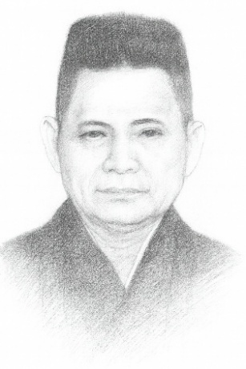
TATSUO SHIMABUKU
Shimabuku Tatsuo was born in Okinawa on September 19, 1908. He began his study of Karate at the age of 8 when he walked some 12 miles to the neighboring village of Shuri to learn Karate from his uncle, Urshu Matsumura (Kamasu Chan). His uncle sent him home; Obstinately he returned and was sent away several more times. His uncle finally gave in and accepted him as a pupil. Shimabuku remained for a period of four years and was only permitted to study Karate after completing the daily menial chores in the dojo.
Having achieved a certain degree of skill in SHURI-TE Karate, he went on to formal training in KOBAYASHI-RYŪ (Shorin-ryū) under Chōtoku Kyan who at that time was famous throughout Okinawa. Shimabuku also studied with Chojun Miyagi of the GOJU style and became his leading pupil. Later he returned to KOBAYASHI-RYŪ this time under the guidance of Choki Motobu, who was virtually a legend in Okinawa. Still seeking more knowledge, Shimabuku studied the art of the Bo and Sai and the Tonfa. He gained this knowledge from Taira Shinken and Yabiku Moden who were responsible for providing Okinawa’s instructors with these particular weapon skills.
Shimabuku’s reputation throughout Okinawa reached its peak when World War II struck. During the early part of the war, he avoided being drafted into the Japanese Army by escaping into the countryside where he worked as a farmer. As the situation became more desperate and the need to press the Okinawans into service became urgent, Shimabuku was again forced to flee. As his Karate reputation spread, many Japanese soldiers organized a thorough search for Shimabuku in order to study Karate from him. The officers who finally located him agreed to keep his whereabouts silent if he would teach them Karate. It was in this manner that Shimabuku survived the war.
Following the war, he returned to farming and practiced Karate privately for his own spiritual repose and physical exercise. As the island’s leading practitioner of both Shorin-ryū and Goju-ryū. Shimabuku experienced a strong urge to combine the various styles of Karate into one system. After consultation with some of the Okinawan masters, Shimabuku founded the Isshin-ryū system—the One Heart Method.

The U.S Marines stationed on the island of Okinawa sought Shimabuku out and he began teaching them Karate. At a demonstration, he missed the nail he was driving into a board with his fist and cut the back of his hand. He put a handful of dirt on the hand and finished the demonstration. Some of the Marines, impressed by his skills and manner, became Black Belt instructors and spread Karate throughout the United States.
Shimabuku formed the Isshin-ryū system on January 15, 1956. In 1966, Master Shimabuku visited the United States, meeting with the students he had taught on Okinawa and instructing their students. Master Shimabuku died on May 30, 1975 at 10:45 PM. Isshin-ryū Karate will continue to be taught and enjoyed by those who have captured the beauty of the vision of Master Tatsuo Shimabuku.

Note: Armstrong says he began going to his uncle’s home at 6 years old and was accepted as a student at 8 years old (2 years as a deshi). Also states that he walked 6 miles to dojo rather than 12 miles.

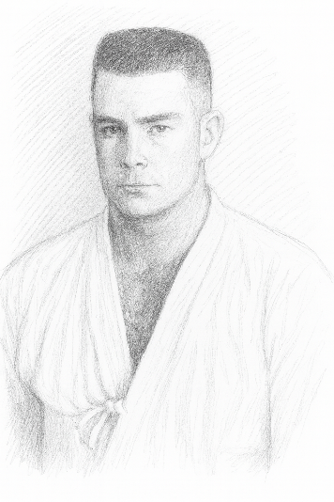
STEPHEN ARMSTRONG
Steve Armstrong was born in Guymon, Oklahoma on September 22, 1931. He began his study of Karate when he was 16 years of age. Steve says, “I was a young Marine a long way from home and I was looking for something to do during my off duty hours.” “I watched a group of Japanese karateka through the window of a dojo in Kobe, Japan and I decided to go in and show them a thing or two.”
Things just didn’t go right for Armstrong because when he started in Karate he was not quite willing to accept that Karate was a self-defense and that the object was to avoid fighting if at all possible. He thought, “why do all this training if you were not going to fight.”
He studied at the dojo not far from the train station in Kobe, but had to take some time out for a trip into China in 1949, until his tour of duty was up later that year. Having achieved a Black Belt and having spent a year and one-half in the Orient, he was really looking forward to a tour of duty in the United States.
After a 30 day leave he found himself back in Japan, this time at the Marine Barracks in Yokohama. He again started in Karate, but was required to start as a white belt as this was a different style of Karate. Again he achieved a Black Belt status and then one day in July his outfit left for the Korean War in 1950.
After serving in Korea, Armstrong returned to the U.S. and was stationed at the world famous Marine Barracks in Washington D.C., where he was on the Presidential Honor Guard for President Truman. During these years he continued to study Karate on his own and decided to leave the service and go to college at the University of Texas. After leaving school, Armstrong again enlisted in the Marine Corps, where he was this time stationed in Okinawa and met TATSUO SHIMABUKU, the founder of Isshin-ryū Karate. Although already a Black Belt in two different styles of Karate, he again was required to start as a white belt.
Under the tutelage of Shimabuku, Armstrong flatly states, “this is where I started learning Karate and what it is all about.” “My other instructors were good, but I wasn’t a good student.” “Karate was only a method of fighting for me, until I met Shimabuku.” Prior to leaving Okinawa for the last time, Armstrong had become Shimabuku’s number two student, second only to the fabulous Harold Mitchum.
Master Steve Armstrong, a 9th degree Black Belt, established the Isshin-ryū Karate School in his garage in 1960, then moved to downtown Tacoma, the YMCA, then to Washington Street and finally expanded into several locations including a few of the colleges and Universities in this state. Master Armstrong firmly believes that Karate has a truly great future.

4 Isshin-ryū Pioneers in U.S.A
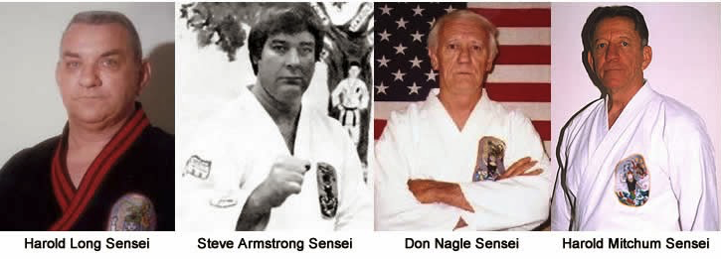

THE TRUE MEANING OF THE ISSHIN-RYŪ EMBLEM

This colorful emblem, with its deep and profound meaning, illustrates a vision experienced by Tatsuo Shimabuku during his development of the Isshin-ryū system and symbolically expresses his goals. While interpretations of the symbols may vary, the interpretations listed below are fairly standard:
WOMAN: A sea goddess, half-serpent, named “Mizu-
Gami,” symbolizing the quietness a Karate
student should exhibit, but having the strength
of the serpent if needed.
LEFT HAND (Open): Represents peace.
RIGHT HAND (Clenched): Represents strength if evil
prevails.
DRAGON: An old Oriental legend that the Dragon is a
god and rises from the Sea to the Sky. The
Dragon has forced himself above the troubles of
life and the world into the peace and quiet
that we all see through the knowledge of Karate.
Sign of good luck; that Isshin-ryū Karate will
prosper. Some people find significant the fact that
Master Shimabuku’s first name “Tatsuo” means “Dragon Boy.”
IS: Means God
SHIN: Means Mind
THREE STARS: May represent virtues, growth or aspects of Isshin-ryū
Karate: physical, mental, spiritual; the three masters under whom
Master Shimabuku studied; Shorin-ryū and Goju-ryū Karate as the
parents and Isshin-ryū Karate as the offspring.
GRAY BACKGROUND: Represents calm and quiet nights and that Karate is to be
used for defense only.
TROUBLED WATER: Indicates a typhoon, danger that cannot be seen; the
trouble of life, to be mastered through the discipline of Karate
training.
In essence, the symbols are saying that you should avoid trouble if possible and use Karate only as a last resort for defense. Therefore, the human being should strive for a strong body and peace of mind through the practice of ISSHIN-RYŪ KARATE-DO. This symbol is the character of SHIMABUKU TATSUO.

REQUIREMENTS FOR PROMOTION TO YELLOW BELT
- Complete dojo procedure:
  - Rules of the dojo
  - Formal procedures of the dojo
- History of Isshin-ryū Karate
- History of Master Shimabuku
- Meaning of the Isshin-ryū patch
- Count 1 to 10 in Japanese
- Explain the importance of the Kiai
- Explain the importance of meditation
- Perform and explain the 15 basic hand techniques and the 5 kicks
- Karate vocabulary
- Perform 2 minutes of continuous sparring in the ring showing great spirit, kiai and strong techniques. You must score 2 solid points on your opponent before time runs out.
- Perform Seisan Kata satisfactory and explanation of each movement.
- FOUR MONTHS of study as a white belt; exceptions will be made upon the discretion of the instructor.
- Write a one page paper on “What has Karate done to me physically and mentally.”

FEATURES OF ISSHIN-RYŪ KARATE
There is no fancy techniques. The Okinawans used to hide the Karate’s killing power because it was against the law to practice Karate.
The best combinations of techniques of Shorin-ryū and Goju-ryū to form a basic and realistic system of self-defense.
The use of low kicks. Low kicks allow you to move more quickly with power and balance. Low kicks are hard to see and hard to block.
The use of short, natural stances which eliminate wasted motion and major body shifting, giving a split-second time advantage in street self-defense situation.
In the katas, the hand and foot techniques are about 50-50 to give a student a well-rounded system of Karate.
Good for close-in techniques which are valuable for street fighting.
Snap punches and kicks enabling you to move in and out quickly in a self-defense situation. The lack of full extension of the limb prevents excessive wear and tear on the hinge joints.
Elements of hard and soft blocking.
Blocks executed with the muscular part of the forearm rather than the bone part to prevent breakage of the bones.
A fist made with the thumb on top of the fist rather than over the first two fingers. This locks the wrist, helps prevent the fist from buckling at the wrist on impact. It also tightens the fist by allowing tension on the top of the fist and the side of the fist.
Vertical punch increases the speed and focus of the punch.
Multiple-purpose technique which allows a block to become a blow and vice versa, making the shift from offense or defense a matter of split-second timing.

You are neither in the Service, nor the Arena, nor at a party, nor in the Jungle of Business, but in the DOJO for YOUR sole benefit. Soley to preserve your life and to develop your finest human qualities. This is too rare a thing not to be respected and should be followed with unshakeable perseverance.

CODE OF KARATE

- A person’s heart is the same as heaven and earth.
- The blood circulating is similar to the moon and sun.
- The manner of drinking and spitting is either hard or soft.
- A person’s unbalance is the same as a weight.
- The body should be able to change directions at any time.
- The time to strike is when the opportunity presents itself.
- The eye must see all sides.
- The ear must listen in all directions.
-Sensei Tatsuo Shimabuko

Over the years many things have been written about Karate and its meanings, but the further you study Karate the more professed the code of Isshin-ryū Karate and the Creed of Karate will become to you.

CREED OF KARATE

I COME TO YOU WITH ONLY “KARATE” EMPTY HANDS. I HAVE NO WEAPONS, BUT SHOULD I BE FORCED TO DEFEND MYSELF, MY PRINCIPLES OR MY HONOR, SHOULD IT BE A MATTER OF LIFE OR DEATH, OF RIGHT OR WRONG, THEN HERE ARE MY WEAPONS – “KARATE” MY EMPTY HANDS.
-Sensei Ed Parker

CODE OF KARATE

The Code of Karate is subject to many interpretations. Within the code lies some of the basic principles of the Isshin-ryū System. Students should think through the various parts of the Code and apply the ideas to your own given situation.
A PERSON’S HEART IS THE SAME AS HEAVEN AND EARTH
- The earth is limited, while heaven knows no limits. Man has characteristics of both, as evidenced by the fact that he is both the strongest, yet the weakest being in the universe.
- The key word is HARMONY; that is man and his environment. If he has no quarrel, then there is no need to fight.
Shimabuku relates a story of an old Chinaman who was traveling through the countryside when a horrible storm broke loose. Upon seeking shelter in a nearby cave, the old man found himself face to face with a tiger who had, himself, fled the elements and sought shelter in the cave. The old man, for he was wise with his many years, had no interest in anything but shelter and made no motion toward the tiger whatsoever. The tiger also bore no malice toward the old man and in this manner they shared the cave together. They both had something in common and were in harmony. So, if man has no quarrel, there is no need to fight.
THE BLOOD CIRCULATING IS SIMILAR TO THE MOON AND SUN
- A person should always remain in motion, should circulate. As a result, in facing an obstacle, he will bend, yet never break.
- The moon and sun are necessary to life itself. Without their energy and growth cycle, plants could not survive... therefore, man would perish also. Animals must move of they will die, for they must move to seek food and shelter. So is it with the blood, it must move or we will die just like a plant that has been broken. Without the moon and sun and their effect on environment, existence itself would be impossible.
THE MANNER OF DRINKING AND SPITTING IS EITHER HARD OR SOFT
- I reference to combat techniques, if one becomes angry (hard), his unbalance is destroyed, but if he remains calm (soft), balance is maintained. When blocking a blow it is possible to meet the attack head-on, force against force (hard) or deflect or parry the blow by you, dissipating its force as it goes (soft). Good self-defense techniques are often the results of turning both hard and soft movements to produce the desired results.
- Consider the relationship between the hand that strikes (hard) and the hand that is withdrawn (soft), between the hand that blocks (hard) and the hand that is withdrawn (soft). It is to be hoped that a student will come to have a good grasp of the relationship, of hard becoming soft and soft becoming hard. With the practice of katas, one seeks the root of the universe.
Master Steve Armstrong, 9th Dan, recalls an incident in Okinawa. There is a peaceful little village called Yoshiharri whose beauty is well known. It was also off-limits to American servicemen stationed nearby. True to human nature the forbidden became the most desirable and it was only a matter of time until several Americans decided to visit the town...off-limits or not. There were those in the village who wished the town to remain Okinawan at all costs. When the American tried to take over, a terrible fight ensued, and an American army captain was killed. The American, who were not supposed to be there in the first place, became incensed at the captain’s death and a series of vicious encounters followed. Eventually armed guards were stationed around Yoshiharri to prevent trouble from starting again. The village, which had been quiet and peaceful (soft) found it necessary to become violent (hard) so that it could once again become quiet and peaceful.
A PERSON’S UNBALANCE IS THE SAME AS A WEIGHT
- Anytime one is unbalanced, that serves as an additional obstacle which must be overcome.
- I takes a minimum effort by your opponent to upset you if you are unbalanced and you will fall as if though you were hit by a great weight. This principal is applied in virtually all phases of life.
THE BODY SHOULD BE ABLE TO CHANGE DIRECTION AT ANY TIME
- The body should be able to respond to situations instead of allowing the mind to anticipate or attempt to “out guess” events.
- In its self-defense reference this means being able to meet attackers from any direction. When most weight is placed on one foot, the other is able to be free to meet the attacker quicker, and without upsetting the weight of the body. To be ultimately successful, whether at living or self-defense, one must be able or be aware of everything around him and be able to defend and change directions to face new problems as they arise.
THE TIME TO STRIKE IS WHEN THE OPPORTUNITY PRESENTS ITSELF
- Always examine your opponent and attempt to locate his weakness. After finding his weakness, attack the point.
- In any strata of society, the people who get ahead are those who can spot opportunities and are not afraid to act on them.

- This concept is of utmost importance in self-defense situations where opportunities may come in only split-second decision. If a drunk in a bar says he is going to hit you and then reaches for a beer bottle, you know it is time to move. By his own words he has already made it a self-defense situation and it is the fool who will wait for the beer bottle to start to swing before he moved to defend himself.
THE EYES MUST SEE ALL SIDES
- Literal application of this idea means developing agility in the use of peripheral vision. The next time you are walking down the street, try walking with your eyes ahead in a natural unfocused attitude. As this comes more easily to you, you will notice that movements and object on either side are much more easily registered. This is applicable in human relations by trying to always consider the other man’s view of the situation. Most things in life, ideas included, take on a new meaning when re-examined from another viewpoint.
- In sparring, whether in the dojo, tournament or on the street, never take your eyes off of your opponent.
THE EAR MUST LISTEN IN ALL DIRECTIONS
- This obviously ties in with point seven above. It is impossible to “see” another person’s point of view until you “hear” his reasons for thinking that way.
- One must be aware of all things about him. One must use the perceptive power to develop all senses to their fullest. The next time you are in a crowd of people listen carefully to conversation beside and behind you. With a little practice you will be surprised at how much more interesting life can be than by restricting yourself only to what is directly in front of you.
With comprehension of these basic principles it is easier to relate them to life and, indeed, to each other. Are you in harmony with all things so that your movement can be either blocking or deflecting without your being off-balance so that you can change direction at any time and to strike when the opportunity presents itself as you look and listen in all direction? The purpose of these Codes and the philosophies of other styles is to elevate you.
Having the fastest side kick in the dojo is of little importance if you do not understand when to use it, and more important when not to use it. Increasing your perception of life around you will make you grow as an individual. We must turn to the philosophies of our arts to give us insight into what it really means to be a master of Karate. It is and endless quest. For those who are the real masters are still searching for even deeper truths.

Although the basic forms of individual self-defense are probably as old as the human race, the art of Karate as it is practiced today can be traced directly to the Okinawan technique called, in Japanese Okinawa-te (Okinawan hands). This in turn is a descendant of the ancient Chinese art of Ch’uan-fa or Kempo (fist way).
Okinawa, a word which means “Rope in the offing”, is a fitting name for this rough and beautiful island, which is thin, knotted and looks like rope. The island is located between Taiwan and Japan, with dimensions of 485 square miles, 65 miles long, and from 2 to 12 miles wide. The climate is comparable to Palm Beach, Florida with average temperature range from 90 degree F in summer to 40 degree F in winter, with constantly high humidity. An average of 200 rainy days each year, with an average of two typhoons passing through the area each month from May to November.
The largest of the Ryūkyu Islands, it possesses a Martial Arts tradition and consists primarily of Empty Hand fighting techniques, but also includes some development of stick and projectile weapons.
Around 1470 the private ownership of arms was restricted, and swords were no longer permitted as personal weapons. All weapons were stored in a government warehouse under the direct supervision of the King’s officers. The effect of this ban on weapons was to stimulate empty-handed fighting methods. In the early 17th century (1609) Okinawa was invaded and defeated by Japan, though Okinawa still paid tribute to China. Under Japanese control, Okinawans could develop no Martial Arts practices. Two styles which became known as Okinawa-Te were Shuri, which was referred to as the internal system and Naha which was external.
Okinawa was overrun by the Satsuma clan of Japan in 1609. Shimozoa Satsuma confiscated everything resembling weapons and blacksmiths were forbidden to manufacture any edged weapon. The importation of any sort of weapon was rigidly forbidden.
Karate remained a secret, hidden and underground through the centuries. Japanese invaders were often found dead; stories and rumors spread. But nothing was written, no archives were kept and the only things known about Karate to the outside world came from the statistics on the number of invaders who fell victim to its practitioners.

IMPORTANT EVENTS IN KARATE

A.D. 525 – Bodhidharma, a Buddhist monk, crosses the frontier from India to China and teaches a system of self-defense along with the religion.
618-906 – Karate, or a form of “ch’uan fa” comes to Okinawa from China.
1350-1399 – Reign of Sato. During this period, relationships with China begins, and Okinawa becomes a tributary of China (1372).
1393 – Surge in the migration of Chinese to Okinawa.
1420 – Ties established with Japan.
1429 – Kang Shoskin issues an edict prohibiting the practice of martial arts.
1609 – Shimazu of Japan prohibits all weapons after conquering Okinawa
1629 – Resistance groups composed of “ch’uan fa” and tode societies band together, creating a new fighting style called “te” (hand).
1724 – Sakugawa of Shuri makes a trip to China to learn “ch’uan fa” and later returns to found the Sakugawa School of Karate.
1840 – Master Kanryo Higaomma is born. He created Naha-te, and is considered the father of Goju-ryū.
1879 – Okinawa becomes part of the Japanese Empire. The secret Karate societies begin a period of intense rivalry among themselves, giving Karate a bad reputation.
1904 – Karate is officially adopted as part of the physical education program in the Okinawan schools with the aid of Anko Itosu.
1908 – Master Tatsuo Shimabuku, founder of Isshin-ryū style, is born.
1922 – Gichin Funakoshi demonstrates Karate publicly in Japan.
1933 – Master Miyagi presents an article entitled “An Outline of Karate-Do” to the largest martial arts organization at that time. As a result of his presentation, Karate is recognized formally as a Japanese martial art.

1936 – Funakoshi established the Shotokan school and adopts free sparring.
1936 – The Okinawan newspaper “Ryūku Shimpo Sha” sponsors a conference of Karate masters which standardizes the Karate ideogram.
1945 – American invasion.
1946 – Robert Trias brings Karate to the United States and establishes the first “known” Karate school in America in Phoenix, Arizona.
1954 – Master Tatsuo Shimabuku begins teaching his system of Karate called “Isshin-ryū”.
1957 – The first ALL Japan Karate Championship Tournament is held.
1963 – American sport Karate begins.
1972 – Okinawa returned to Japan.
1973 – Bruce Lee, a superstar of Karate films, dies.
1975 – Master Tatsuo Shimabuku dies.

KARATE VOCABULARY
Aswatte – sit Makiwara – striking board
Bo – wooden staff Matte – wait, stop
Dachi – stance Mawatte – turn
Dan – black belt holder Nukite – finger tips
Dojo – martial arts gym Obi – belt
Empi – elbow Randori – free style match (Judo)
Geri – kick Rei – bow
Gi – suit Ryū – school
Hajime – begin Sai – traditional tipped knife weapon
Isshin-ryū – one’s heart Sensei – teacher
Ippon – one point Shihan – master
Jiyu-Kumite – free style sparring Shiai – promotional match
Karateka – student of karate Shuto – side of hand
Kata – formal exercise Simban – referee
Ki – inner spirit Yamein – stop, rest, at ease
Kiai – controlled shout Tashi-rei – standing bow
Kime – focus Ush – stop
Kiotsuke – attention O-Hayo – good morning
Kumite – free style fighting Konnichi-Wa – good day
Kyu – brown belt and below Komban-Wa – good evening on meeting
Dozo – please Domo Arigato – thank you very much
Sayonara – good-bye O-Yasumi Nasai – good night upon parting
Arigato – thank you
USE THE ABOVE TERMS AND WORDS WHEN IN CLASS!
COUNTING
ICHI – 1 (Ik, Sho) ROKU – 6 JU ICHI – 11 JU ROKU - 16
NI – 2 SHICHI – 7 JU NI – 12 JU SHICHI - 17
SAN – 3 HACHI – 8 JU SAN – 13 JU HACHI - 18
SHI – 4 (Yon, Yo) KU – 9 JU SHI – 14 JU KU - 19
GO – 5 JU – 10 JU GO – 15 NI JU - 20
RANK SYSTEM – KYUS
JU-KYU – 10th degree white belt GO-KYU – 5th degree green belt
KU-KYU – 9th degree white belt YON-KYU – 4th degree purple belt
HACHI-KYU – 8th degree yellow belt SAN-KYU – 3rd degree brown belt
SHICHI-KYU – 7th degree orange belt NI-KYU - 2nd degree brown belt
ROKO-KYU – 6th degree blue belt IK-KYU – 1st degree brown belt
DANS
SHO-DAN – 1st degree black belt ROKO-DAN – 6th degree black belt
NI-DAN – 2nd degree black belt SHICHI-DAN – 7th degree black belt
SAN-DAN – 3rd degree black belt HACHI-DAN – 8th degree black belt
YO-DAN - 4th degree black belt KU-DAN – 9th degree black belt
GO-DAN - 5th degree black belt JU-DAN - 10th degree black belt
6th, 7th, and 8th Dan may wear a red and white belt, 9th and 10th Dan may wear a red belt.
Some of the variety of areas that can be used to deliver Karate blows. Dark areas indicate areas of contact.
A. Head I. Spear finger
B. Fore fist J. Elbow (up or down)
C. Hammer fist K. Elbow (back or forward)
D. Thumb knuckle L. Knee
E. Palm Heel M. Edge of foot
F. Knife hand N. Instep
G. Ridge hand O. Heel of foot
H. Spear hand P. Ball of foot
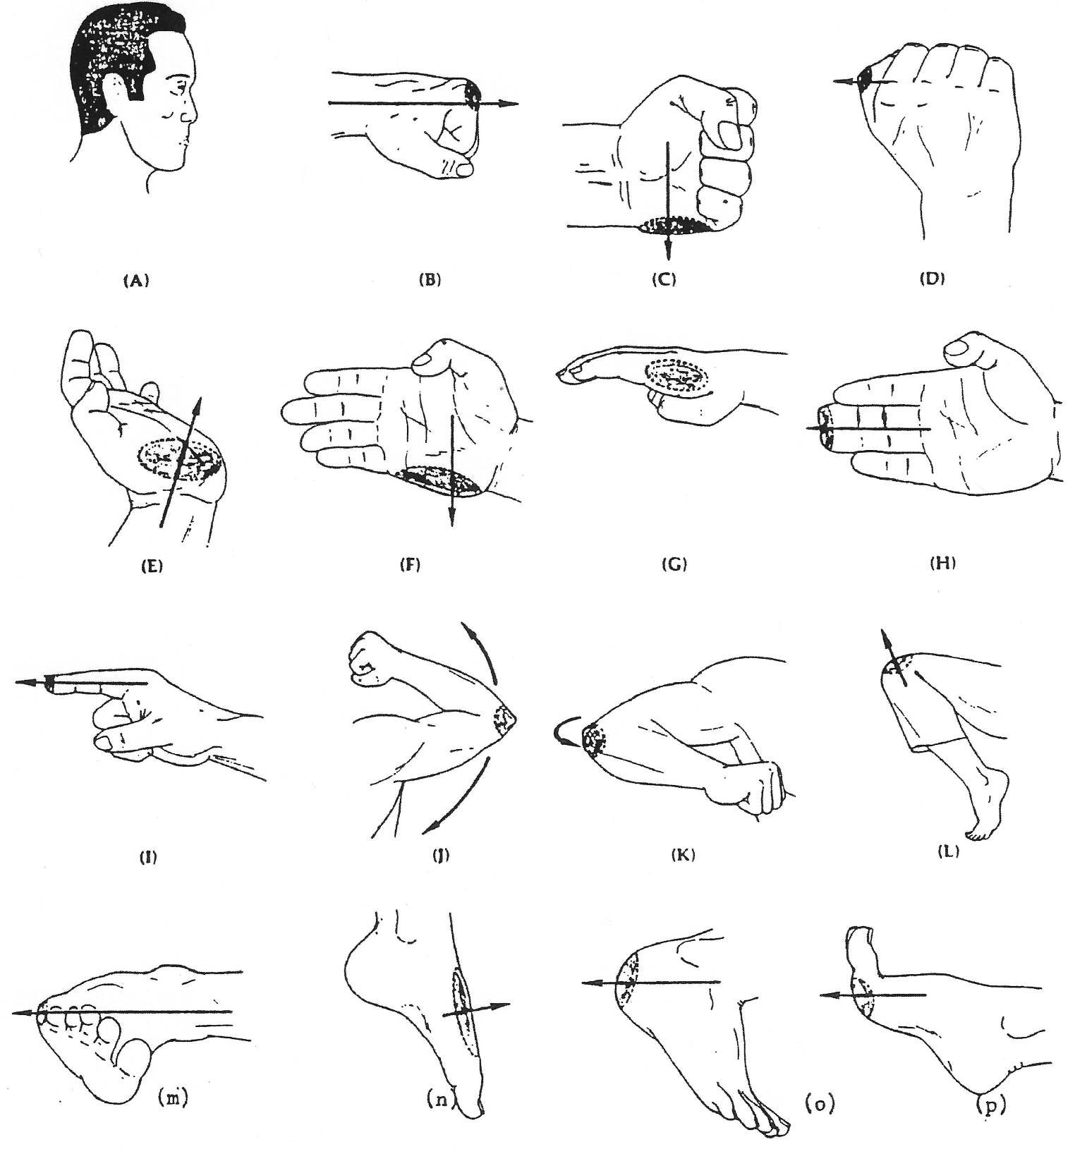
VITAL POINTS OF THE BODY
1. Bridge of nose 16. Shin
2. Temple 17. Ankle
3. Eye 18. Skull
4. Philtrum – base of nose 19. Back of neck
5. Chin 20. Center of back
6. Side of neck 21. Elbow
7. Adam’s apple 22. Wrist
8. Collar bone 23. Kidneys
9. Arm pit 24. Coccyx
10. Solar plexus 25. Back of thigh
11. Front of elbow 26. Side of knee
12. Ribs 27. Back of knee
13. Abdomen 28. Instep
14. Testicles 29. Achilles tendon
15. Knee

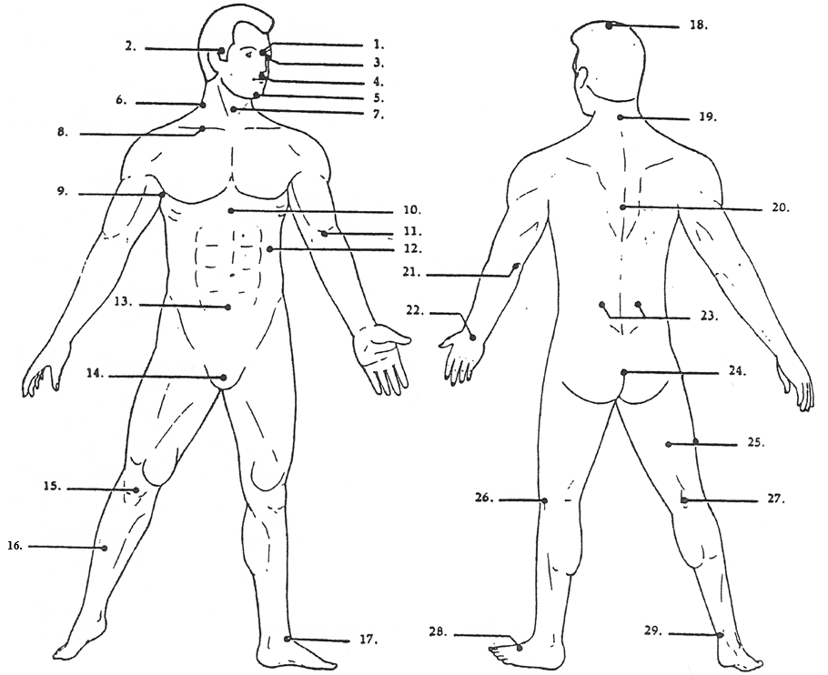
PRESSURE POINTS
1. TEMPLE: The small depressed area which is ordinarily exposed and
available. It is back about one half inch from the ridge of
bone that surrounds the eye. A moderate blow will cause
pain, as there is a concentration of nerves at this point.
A heavy blow will stun or cause unconsciousness, while a
full power blow can be fatal.
2. NOSE: Striking down onto the bridge, or striking upward under the
nose causes great pain and bleeding.
3. UNDER THE EAR LOBE: There is a sensitive area which is immediately
behind the ear lobe. A digging action into this spot causes
great pain.
4. UP UNDER THE JAW: In the fleshy area of the neck on each side of
the windpipe, behind the jawbone, there is a sensitive area
which can be hurt easily by a digging action.
5. SIDE OF NECK: The area between the ear lobe and the shoulder
muscle. Here is a heavy concentration of nerves, as well as
exposure of vein and artery which supply blood to the
brain. A moderate blow to this area can cause pain and
confusion. A heavy blow can cause unconsciousness. A very
heavy blow can cause permanent paralysis.
6. NECK MUSCLE: The long muscle that runs from under the jaw down
to the collar bone, in the middle of which there is a
nerve. A slight digging pressure will result in discomfort.
A finger stab will result in great pain.
7. WINDPIPE (Adams Apple): A digging pressure causes great pain,
choking and gasping. A light hitting blow can stun. A
medium blow could result in unconsciousness. A heavy blow
could be fatal.
8. SHOULDER MUSCLE: At the base of the neck where it joins the
shoulder, is a concentration of nerves and muscle. A light
blow to this area causes discomfort. A medium blow results
in temporary numbness. A heavy blow can immobilize the arm
for a short period.
9. HOLLOW OF THE THROAT: This area is the small depression below the
windpipe. Striking this area can be fatal.
10. SOLAR PLEXUS: Where the ribs part, just below the breast bone.
A light to medium blow to this area will “knock the wind”
out of a person. A heavy blow can be fatal.

11. SIDE OF BODY: Just below the last rib. Blows to this area causes
pain.
12. ELBOW: In the inside bend of the elbow there is a concentration
of nerves. By striking this area, the arm can become numb
or paralyzed for several minutes before regaining use.
13. FOREARM: Very slight finger pressure will result in pain. A
moderate or heavy blow can numb or paralyze the arm for
several minutes.
14. ABDOMINAL AREA (Bladder): A blow struck very low into the center
of the abdomen will hit the bladder. A light blow will
cause pain. A medium blow will double up your adversary and
stun. A heavy blow could rupture the bladder, which might
be fatal.
15. GROIN: A light blow to the groin area results in great pain. A
medium blow will stun or cause unconsciousness. A heavy
blow can be fatal.
16. INSIDE OF THIGH: A light blow is ineffective. A medium blow will
cause adversary to limp. A heavy blow could temporarily
immobilize the leg or cause a cramp.
17. KNEE: It takes only about six lbs. pressure to dislocate a knee
cap.
18. SHIN: This is an area of exposed nerves, which is extremely
painful, even with the slightest blow.
19. ANKLE BONE: The round bone at the inside and outside of the ankle
is a very sensitive area. A light blow will result in a
great deal of pain. A medium or heavy blow causes intense
pain.
20. INSTEP: On top of the foot is a sensitive area which when struck
with moderate force causes great pain. A heavy, smashing
kick onto the instep can result in broken bones.
21. BASE OF THE SKULL: There is a very thin line between an
ineffective blow and a paralyzing blow. A heavy blow to
this area could dislocate the vertebrae and cause
permanent paralysis.
22. SEVENTH VERTEBRAE: There is little muscle to protect this area,
and a very thin line between an ineffective blow and a
blow that will paralyze.
23. BETWEEN THE SHOULDER BLADES: A light blow is ineffective. A medium
blow could stun. A heavy blow could be fatal. The result of
such a blow is to refer shock to the heart and other vital
organs.

24. BACK OF THE ARM: Midway between the shoulder and elbow is a
sensitive area. Slight or moderate finger pressure will
result in pain. A moderate or heavy blow can numb or
temporarily immobilize the arm.
25. KIDNEY AREA: A moderate blow in this area causes great pain. A
heavy blow can be fatal.
26. COCCYX (Tail bone): A light blow is ineffective, however, a heavy
blow can cause serious permanent damage.
27. BACK OF UPPER LEG: A light blow is ineffective. A medium or heavy
blow could temporarily immobilize the leg.
28. BEHIND THE KNEE: A blow to this area can cause pain, loss of
balance and impairment of the use of the leg.
29. CALF: A light blow is ineffective. A medium or heavy blow can
temporarily immobilize the leg.
30. TENDON: Just above the heel at the back of the leg is the
sensitive area known as the Achilles Tendon. A light blow
is ineffective. A medium blow causes great pain. A heavy
blow can result in a torn tendon, making it difficult or
impossible to walk.
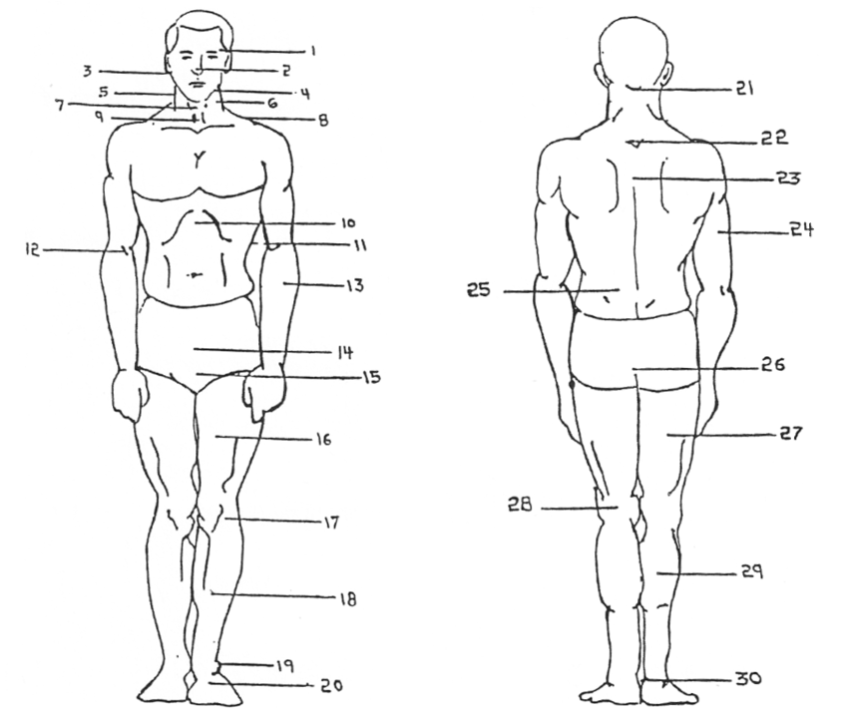

ISSHIN-RYŪ KARATE WORKOUT
1. EXERCISES
1. Breathing
2. Jumping Jacks
3. Neck Rotation
4. Arm Rotation / Toe Raise
5. Body Twist
6. Toe Touch / Finger Tip
7. Back Bend
8. Toe Touch / Palm
9. Back Bend
10. Knee Rotation
11. Finger Lock
12. Side Squats
13. Jump on Ball of Foot
14. Ankle Rotation / Toe Bends
15. Push-Up / Knuckles
16. Push-Up / Fingertips
17. Sit-Up
18. Breathing
2. STRETCHING
1. Standing Ankles Grab
2. Right/Left Ankle Grab
3. Cobra
4. Sitting V-Shape Ankle Grab
5. Butterfly
6. Feet to Body
7. Right/Left Foot Grab
8. Toe Touch
9. Knuckles/Fingertips Push-Up
10. Kneeling Right/Left Thigh Stretch
11. Splits
12. Fire Hydrant
13. Squat-Knee Stretch
14. Shin/Thigh Conditioning
15. Breathing
3. BASIC HAND TECHNIQUES
1. RF forward, RH lunge punch
LF forward, LH lunge punch
2. RF forward, RH Uppercut
LF forward, LH uppercut
3. RF forward, LH reverse punch
LF forward, RH reverse punch
4. RF forward, LH reverse uppercut
LF forward, RH reverse uppercut
5. RF back, LH down block, RH reverse punch
LF back, RH down block, LH reverse punch
6. RF back, LH body block, RH reverse punch
LF back, RH body block, LH reverse punch
7. RF back, LH knife hand block, RH spear hand strike
LF back, RH knife hand block, LH spear hand strike
8. RF back, LH knife hand overhead block, RH reverse uppercut
LF back, RH knife hand overhead block, LH reverse uppercut
9. RF back, LH overhead block, RH reverse punch
LF back, RH overhead block, LH reverse punch
10. RF forward, RH back fist strike, LH reverse punch
LF forward, LH back fist strike, RH reverse punch
11. RF forward, RH down block, LH starts 5 strong punches
LF forward, LH down block, RH starts 5 strong punches
12. RF forward, RH body block, LH starts 5 rhythm punches
LF forward, LH body block, RH starts 5 rhythm punches
13. RF forward, RH parry, LH roundhouse punch, RH roundhouse punch
LF forward, LH parry, RH roundhouse punch, LH roundhouse punch
14. RF forward, RH open knife hand to the body, LH open knife hand to the neck
LF forward, LH open knife hand to the body, RH open knife hand to the neck
15. RF back to Cat Stance, RH elbow strike with hip, LH breakaway
LF back to Cat Stance, LH elbow strike with hip, RH breakaway
4. BASIC KICKS
1. Front Snap Kick
2. Side Front Snap Kick
3. Side Kick
4. Forward Angle Knee Kick
5. Squat Kick
6. Crossover Kick
7. Knee Smash Kick
8. Heel Thrust Kick
9. Roundhouse Kick
10. Back Kick
RH – right hand, LH – left hand, RF – right foot, LF – left foot

WARM-UP
The term warm-up is accurately descriptive. It refers to the fact that the temperature of the body, including the muscles and the blood, actually does increase during physical activity. To be beneficial, however, the temperature increase must be sufficient to result in certain necessary physiological changes. As a rule of thumb, one may accept light sweating as indication of an adequate warm-up.
Increased muscle and blood temperature permit an increase in both speed and strength of muscular contraction and an increases in the rate at which oxygen can be delivered to and utilized by active muscles. These factors, along with others, result in an increase in speed, strength, coordination, efficiency, and endurance. One’s athletic performance will thereby be improved through a proper warm-up. Even more significant, an adequate warm-up is beneficial in helping to prevent muscle soreness and injury.
There are many ways in which an athlete can warm-up. Passive methods include heating by hot baths, hot showers, steam and sauna rooms and diathermy. These procedures have gained but few followers due to their limitations regarding availability of facilities.
As the name implies, active warm-up methods involve muscular effort by the athlete. Procedures may be divided into two categories, unrelated (general) and related methods. A general mobilization of the body can be brought about by calisthenic exercises and can results in the desired physiological changes.
Related methods employ the same skills that are to be used later in the training session or in competition. In addition to the practice effect, it has all the physiological benefits of the unrelated procedures.

PROCEDURE FOR MAKING THE PROPER ISSHIN-RYŪ FIST
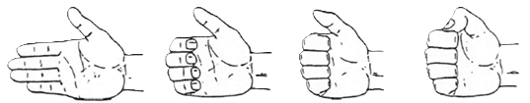
(A) (B) (C) (D)

STRETCHING
Stretching exercises should be stressed during the warm-up period. These are beneficial in increasing one’s flexibility--the range of movement in the joints of the body. Good flexibility makes it possible to have proper alignment of the body, which is necessary for graceful, efficient movement. Most important, flexibility exercises during the warm-up period help to prevent injury to the muscles and tendons during the practice session or competition.
With stretching activities one is not concerned primarily with stretching one’s muscles but with stretching the associated connective tissue. This includes the fascia that surrounds muscle fibers and the tendons by which the muscles are attached to bones. The term, muscle stretching, is very common and there is nothing wrong with using it as long as one is aware of the true meaning.
Connective tissue may be stretched either by employing bouncing (phasic) motion, or by very slow (static) motions. Phasic movements, though utilized most often by athletes, are not es beneficial as static movements. While tendons and fascia are effectively stretched by both kinds of motion, phasic movements are not as easily controlled and may exceed the limits intended at that time. In addition, a muscle that is stretched with jerky motions reacts by contracting (shortening) reflexively. The contractions are diametrically opposed to the desired stretching action. Further, as the bouncing movements intensify in range or speed, the tension in the muscles increases. Besides interfering with the stretching of tendons and fascia, the additional tension increases the likelihood of injury to the muscles.
Static stretching methods which are based on sounder physiological principles are unfortunately seldom employed by athletes. Very slow and deliberate stretching movements actually inhibit contraction in the muscles being stretched. Therefore, the tension in the muscles decreases even though the surrounding and associated connective tissue is being stretched. Research shows that for a given degree of stretch the amount of tension produced in muscles by a jerky motion is more than twice that of a slow stretch. The latter is much less likely to cause muscular soreness or injury. When employing the static procedures, a stretched position should be held for at least one minute for optimal increase in flexibility.
To increase the range of motion in a joint it is necessary to push beyond the usual range. Thus, some degree of discomfort should be experienced. One must be careful, however, not to stretch so far as to cause injury. After stretching a muscle group it usually feels good to relax the muscles and shake them rather vigorously.
In warming up and stretching, the instructor must be prepared to allow for individual preferences, especially in the case of the experienced athlete. An enforced and complete departure from his usual warm-up procedures may psychologically hinder such a person in performing at his best. However, it does behoove every athlete to seriously consider the preceding suggestions which are based upon sound physiological factors.
Besides the physiological variations, there are many physical differences among individuals. One person, for example, may be “tight” in the shoulder region but “loose” and flexible in the lumbar (lower back) region. Another person may be just the opposite. Because of the individual physical differences, it is impossible to devise a specific warm-up and stretching routine that will be of optimum benefit to all. Presented below is a general warm-up program that may be followed prior to karate competition or a practice session.
1. Stretching Movements--At first, employ very slow
movements with special attention to those joints that
require extra stretching. If the athlete feels phasic
stretching motions must be included, they should follow
the static ones.
2. General Activity Exercises--Involve the large muscle
groups and continue to the point of light sweating.
3. Related Activity Exercises--Practice specific karate
techniques - punches, kicks and blocks. The advanced
karateka should practice a kata. Stop warming up about
10 minutes before sparring or competition is to begin.
4. Light Sporadic Movements--This is basically a rest period
during which the athlete delivers an occasional punch or
kick at an imaginary opponent. A few stretching or
exercise movements should also be included to maintain
the warmed-up condition. This warm-up may be a bit too
strenuous for the beginning karateka. If so, this
indicates that he or she has not yet reached a
satisfactory level or physical fitness.
A thorough, but not exhausting, warm-up is extremely important. It has been wisely stated that, “If the warm-up is right, the performance is a cinch—it’s all downhill.”
Usually, one begins by exercising the neck muscles and works down to the ankles. In this way all of the body parts are warmed up and stretched. Each exercise should begin with slow stretching movements with the range of motion being small at first and then increasing. the exercises should also be performed with increasing vigor to achieve a warmed-up condition. How rapidly one progresses from slow to vigorous movements depends upon individual and environmental conditions. On cold days, for instance, one will advance more slowly than on warm days. Morning workouts also require a longer warming-up period. Older people must progress more slowly from slow motion to more vigorous ones. One's sex is also a significant factor. Because men are generally less flexible than women, they require a greater emphasis on stretching activities to prevent muscle soreness and injuries. Due to the many modifying factors it is impossible to prescribe a specific time period for each exercise. As a rule of thumb, one should persist at each exercise until he feels that the active muscles are loosened up. Upon the conclusion of the entire warm-up and stretching session one should have achieved at least a light sweat.

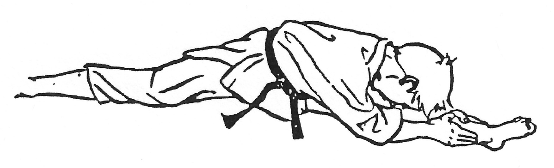

BASIC FUNDAMENTALS IN KARATE TECHNIQUES
Punching, striking, kicking, and blocking are the fundamental karate techniques. They are the beginning and final goal of Karate. Students can easily learn to perform these basic movements in little more than two months, but perfection in their performance may be impossible. Students must practice regularly and put maximum concentration and effort in the performance of each movement. Practice will not achieve its objective if it is undertaken incorrectly. Unless students learn techniques on a scientific basis, under an instructor employing a systematic and properly scheduled training system, their efforts will be in vain. Karate training can be considered scientific only when it is conducted on the basis of correct physical and physiological principles.
The following points are of importance in the study of Karate:
FORM - BALANCE - CENTER OF - GRAVITY
Karate is not the only sport that concentrates on the optimum utilization of the human body or embraces principles taught in physics and physiology. All the martial arts and most other sports depend on correct form for the effectiveness of their techniques. In baseball, good batting form is necessary to attain a high batting average. Correct form is especially important in Karate. All parts of the body must harmonize to provide the stability necessary to sustain the shock of delivering a kick or punch.
The Karate student must often stand on one foot to attack or defend. Balance is of prime importance. If the feet are placed far apart, with a consequent lowering of the center of gravity, a kick or punch will be stronger. However, it is easier to move if the center of gravity is somewhat higher and the feet closer together rather than spread to the maximum possible extent. Therefore, although stability is important, there is a point beyond which it is not worth going. If the student is overly concerned with stability, he will lose elasticity. If he bends his knees too much to maintain balance, his kick will not be effective. Thus, the position of the body and consequently, the center of gravity, depends upon the circumstances.
The center of gravity is always shifting. Sometimes body weight is evenly distributed between both feet and sometimes there is more on one foot than on the other. When performing side kick, the weight is completely shifted to one foot. In this case, the student must stand firmly on one leg, otherwise the shock of delivering the kick will upset the balance.
However, if he stands on one foot for too long, his opponent can easily attack. Therefore, his balance must be shifted constantly from one foot to the other. His center of gravity must shift quickly from right to left and back again to avoid giving the opponent an opportunity to attack. At the same time, the student must constantly look for an opening in his opponent’s defense.
POWER AND SPEED
The possession of muscular strength alone will not enable one to excel in the martial arts. The effective use of strength is important. The application of power to any movement depends on a number of factors. One of the most important of these is speed.
The basic punching and kicking techniques of Karate achieve their power by the concentration of maximum force at the moment of impact. This concentration of force depends greatly upon the speed with which techniques are executed. Other things being equal, greater speed will result in increased power. The punch of an advanced karateka can travel at speed of 43 feet per second and generate power to destroy equal to 1,500 pounds.
Speed is an important element in the application of power, but speed cannot achieve its greatest effect without good control.
The kind of movement needed in fundamental Karate techniques is not one which will move a heavy object slowly, but one which will move a light object with maximum speed. Thus, the strong but slow exercise of power necessary to lift a barbell is not as effective in Karate as the power developed by hitting the makiwara (punching) board with great speed.
Another principal to remember is that greater speed can be generated if power travels a longer route to its target. For example, in kicking, the knee of the kicking leg should be bent as much as possible and the body so placed in relation to the target that the leg will be fully stretched at the moment of impact. The longer the course the leg travels to the target, the stronger the kick will be. In order to increase power and speed, it is necessary to practice responding to sudden and unrehearsed attacks. Such practice, together with an understanding and application of the dynamics of movement, will help shorten reaction time.
CONCENTRATION OF POWER
A punch or kick will be weak if applied with the arm or leg alone. To achieve maximum power it is necessary to use the strength of all parts of the body simultaneously. When punching or kicking, power moves from the center of the body, the major muscles, to the extremities, ending in the hand or foot. This power moves from one part of the body to the next at a speed of 1/100 of a second. The whole movement from beginning to end takes only .15 to .18 of a second if the momentum possible in this action is correctly exploited. Training should be conducted so that all available strength is focused in the foot when kicking or in the hand when punching.

It is important that the various muscles and tendons are kept loose and relaxed to permit instant response to changing circumstances. If the muscles are already tense, they cannot be further tensed at the moment of focus.
Power concentrated at the time of focus must be instantly released to prepare for the succeeding action. Constant training in alternately tensing and relaxing of the body is very important to acquire proficiency in the application of Karate techniques.
MUSCULAR POWER
Power to move the body is supplied by the muscles. Well trained, powerful and elastic muscles are mandatory in Karate. Even if the student is well-versed in Karate theory and knows the principles of the dynamics of movement, his technique will be weak if his muscles are not strong enough. Therefore, constant training is necessary to strengthen the muscles of the body.
If Karate training is to be conducted scientifically, it is also necessary to know which muscles are employed in the execution of a particular technique. When practicing a new technique, students sometimes use unnecessary muscles or muscles which actually hinder the performance of the technique. Therefore, beginners must carefully follow the advice of their teachers. When the proper muscles operate fully and harmoniously, the technique will be strong and effective. On the other hand, if unnecessary muscles operate there will result, at the very least, a loss of energy, and at worst an ineffective technique. Finally, the speed of muscular contraction is important, because the faster a muscle is tensed the greater will be the power produced.
RHYTHM
An essential element in the performance of technique in the martial arts is rhythm. The proper execution of a series of movements is impossible without rhythm. Also, the rhythm evident in the movements of athletes is more complicated than musical rhythm. It is essential for the karateka to learn correct rhythm in both the basic techniques and in sparring.
Rhythm is especially necessary in the performance of kata. We have been taught since early times that the three most important elements in kata performance are the application of strength at the correct time, the control of speed in techniques and from technique to technique, and the smooth transition of the body from one technique to the next. These requirements cannot be fulfilled without rhythm. The kata performance of a person advanced in Karate is powerful, rhythmical, and consequently, beautiful.
TIMING
Correct timing is of the utmost importance in applying techniques. If timing is faulty, the technique will fail. A kick or punch which in directed at the target either too early or too late is often fruitless.

The start of a technique is of first importance in any consideration of timing. To start their particular movements more effectively, baseball players condition their swings with practice swings. However, there is no opportunity for anything like a practice swing in Karate, where the outcome can be decided in an instant. A failure in timing could be disastrous.
The attack in Karate must be launched with the hands and feet in the usual position of readiness or defense. Obviously, the hands and feet must always be positioned so that techniques can be easily and quickly applied. Immediately after the application of a technique, they must be returned to their former position, ready for the following movement. Moreover, during the course of these movements the body must be kept relaxed, but alert, with the muscles full of energy and ready for any eventually.
CIRCLE AND POINT
The secret of Circle and Point is that all the movements both with and without outer forms are composed of circles. Those circles may be plane or cubic, straight or slanting, big or small. They make complete circles when they are big and become points when they are small. When used the circle of joint should be distinguished as a Yin or Yang, softness or firmness that is, partly neutralizing and partly giving attack. Moreover a circle may be made from a point and any points on that circle may form another circle. The higher the level of the art one attains the smaller the circles. A beginner need only to know that every movement contains a circle or circles.

BREATHING
Breathing is a reflex, an unconscious response to an automatic pilot with which nature has provided us. At a signal from the brain the chest enlarges and air rushes in; the signal cuts off and the chest relaxes forcing air out. This system of regulating our breathing is so effective that we are rarely aware of its existence. Even when exercising heavily and our lungs feel as if they were going to burst we are usually aware of the feeling of pressure and not of air rushing in and out of our bodies.
This system is good; nature has designed it so we do not need to spend all our time getting air into our lungs. We are free to concentrate on other things, But the martial arts teach us to improve every facet of ourselves, and breathing especially is included in our martial art studies. There are many different breathing techniques which are taught throughout the martial arts. Each method is valid way of achieving the same goals. As long as the student focuses on achieving the control designed by his method of breathing, he will be able to take advantage of the benefits of good breathing.
Too often, the beginner will forget the importance of learning to breathe as he works to develop the strikes and kicks, works on coordination and timing, and tries to develop a sparring system. This is understandable. During his lifetime, he has never had to think about breathing, it just happened. This is why he should set aside some practice time only for breathing. He must use this time to work on his breathing patterns and gradually begin to incorporate movements with the breathing. After a few minutes of practicing his breathing, he might go through his kata. The kata should be done slowly while he concentrates on coordinating the timing and moves with the correct breathing sequence, each move should be carefully worked out in his mind so none are left to the automatic pilot. The moves must be slowed until the brain has learned the proper sequence. After the motion is clearly fixed in the student's mind, he should begin to work for speed. As his abdomen grows stronger and his mind becomes more sure of its control over his breath, he will find that he is able to generate more power in his movements, more speed and focus.
But breathing strengthens more than just the physical man. It strengthens the inner man also, the spirit we know as "ki.” This mysterious force is as much a part of human life as the automatic breathing, in each of us. Just as air flows freely in and out of our bodies, ki flows freely through them. Yet we are unaware of its presence, just as we are usually unaware of our breathing. Control of our ki is a long and laborious task, just as is controlling our breathing. We have spent, many years ignoring both. It would be presumptuous to assume that we will quickly and easily break those old habits. It takes time to change these patterns. It takes patience to invest the time.

But unless you spend the time mastering effective breathing, you will find that the time you spend mastering the techniques of the arts is wasted.
Just as you would die if you failed to breath, the efficiency of your techniques will die if you fail to add the element of breath control, When your instructor tells you to control your breathing, he is directing your attention to a method of breathing. But he is actually asking you to control a much broader range of abilities - your body, your mind, your spirit.
The following, exercises should be practiced as you gain control of breathing.
1. Full Breathing: Get into an Isshin-ryū stance. Breathe
from the lower abdominal area up, filling the body
completely with air.
2. Fractional Breathing: Try to breathe normally with only
1/2 the air being inhaled and exhaled; then with 3/4th
of the air being, inhaled and exhaled. Try to keep at
least 1/4 to 1/3 of the air in you at all times to make
another kiai if necessary. If you realize a blow is
coming, expel about 3/4 of the air and tense your
muscles to avoid being overwhelmed by the blow. If you
have to make a fast defense or counterattack, try to
inhale at least 1/3 of a breath so that you can expel
some air to build force in your block or blow.
3. Combination Yell: Take in a full breath, then exhale 1/3
of the air and yell twice, then exhale the second 1/3 of
the air and yell twice again.
4. Punching - Breathing Exercise: Inhale strongly as you
draw the first back and exhale on delivery of the blow.
To affect the breathing more, hold the punch after
impact and continue to exhale until all the air ls out
of the lungs. Practice this exercise slowly and
deliberately.
5. Toe Touch Breathing: Bend over and let your fingers
touch the floor. Inhale as you raise the trunk of your
body, flinging your arms out to your side. Exhale as you
bring your arms back to your sides and bend over to
touch the floor again.

KIAI
The kiai is an enigma to most beginners. Karate is physically oriented to them. They fail to see why they are taught to yell at certain times during their workouts. The advance students know the importance of the kiai and concentration; concentration and the kiai are the very essence of the art.
All Oriental martial arts possess some form of kiai. Emphasis is placed on the concentration of power and spirit which the kiai brings forth.
A good kiai originates in the lower abdomen which is the center of power. Before performing any action which requires strength, the stomach muscles must be tightened or the action cannot be performed well. In order to practice the martial arts, “Ki”, or energy, is needed. The source of this "Ki" is the abdomen.
To do the kiai, start by filling your lungs with air. Exhale twenty to forty percent of your breath. At this point abruptly stop breathing and tighten your abdominal muscles. This causes the air in your lungs to act much the same as the air brakes used on buses. It follows that Karate practitioners must do stomach exercises to build up these important abdominal muscles as well as the usual stretching exercises.
The release of this air from the diaphragm at the moment of yell will:
1. Speed the flow of adrenalin.
2. Tighten the lower stomach.
3. Focus your attention on your technique.
4. Startle your opponent.
5. Give you self-confidence.
6. Give you 15-20% more power than you would normally
have for use.
Concentration and kiai go hand in hand. They help the martial arts practitioner bring together his heart, mind, and body for the purpose of making his actions strong, quick, and precise. When concentration and the kiai are practiced faithfully, the student is rewarded with better technique, more power, and physical fitness. All these things are innate potentials, but they can be naturally developed through the correct practice of your Karate training.

KATA
WHAT ARE KATA?
Kata are the formal exercises of Karate. They are sequence movements which are learned by the karateka in order to develop rhythm and coordination of techniques. As such they are an integral part of training and they are practiced regularly, along with new techniques, strengthening exercises and sparring.
Kata consist of logical combination of four fundamental movements: blocking - punching - striking - kicking. As he goes through these movements in the dojo, the karateka assumes himself to be surrounded by a number of imaginary enemies. Each movement of his body, hands and feet has its own meaning and function. None is superfluous. They have been developed by past masters of Karate through years of practice.
Today there are approximately fifty forms of kata - some date back to the time when Karate was first used or were introduced from China during the middle ages, while others were developed fairly recently. Some are simple while others are complicated, some long and some short. But each kata has its own characteristics.
Kata can be roughly divided into two types. There are kata which aim at body-building, muscles-strengthening and hardening the bones--movements in these kata are expansive and give the impression of power and strength. There are speed training kata which are designed to produce lightning-fast reflexes.
Because they involve the use of the whole body, kata movements are an ideal form of physical exercise. They can be learned and practiced individually or in groups by anyone--young, old, male or female. They can be done for five minutes or an hour at a time, in the dojo or in the privacy of one's own home.
MENTAL ATTITUDE FOR THE PERFORMANCE OF KATA
CEREMOMONIAL BOW: Karate training begins and ends with a ceremonial bow. To perform this movement, an informal stance is taken with hands relaxed, lightly touching the thighs. The body is then bent forward, while the eyes remain focused straight ahead. Out of respect to his training partner, the karateka must perform the bow with sincerity.
Courtesy and decorum are the first requirements of the karateka. As Tatsuo Shimabuku often told his students: "The spirit of Karate is lost without courtesy.” The karateka must be courteous, not only in training but also in daily life. Furthermore he must be humble and gentle. Yet the karateka must never be servile--he must always perform the kata boldly and with confidence. This combination of boldness and gentleness, which might seem paradoxical to the beginner, ultimately leads to harmony.
POSTURE AND PERFECT FINISH: After bowing at the center of the “kata performance line” the karateka stands with his feet apart toes pointing

outward, in the "open-leg stance" before beginning the kata. If the “closed-feet stance" is taken, the toes are placed together. The karateka must avoid being too tense and must not be over conscious of the movements he is about to make. He must ease the tension in his body, particularly from the joints of the shoulders and the knees, in order to be fully prepared for any slight or sudden movement. Power and concentration should be centered in the "area of the naval”, breathing should be relaxed and the karateka must instill in himself a fighting spirit.
The finish of the kata is most important; for no matter how brilliantly the exercises are executed, if the ending is not good, the kata is not perfect. And even after the kata is over, the karateka must not relax. He must return to his original posture and be prepared for further movements. The Zanshin in Japanese martial arts has always been highly respected and the Karate student should remember that it is important not only in training but also in daily life.
PERFORMING KATA
1. Execute kata correctly and in the right order. The number of movements in each kata is fixed and the student must perform them all, in the right order, without making any mistake.
2. Move accurately on the "performance line”. The performance line is the line from which all the kata movements (forward, backward, right and left) are made. The karateka must complete the kata at the spot from which the first movement was made. This is impossible if the wrong steps are taken or the breadth of steps is inconsistent. Intensive training is necessary to perfect this.
3. Understand the meanings of the various moves and express them fully. The movements of each kata have their own meanings--either offensive or defensive--which the student must understand clearly and express fully.
4. Be aware of the target. The karateka must realize from where his imaginary opponent is attacking, be sure of his target and know when to strike. His attention must not stray from his target, but at the same time he must be aware of further opponents. The karateka must always be aware of the purpose of each move as he performs the kata.
5. Execute each kata clearly. Not only should the meaning of each move in the kata be clearly understood but its characteristics should be clearly performed. Each kata should be interpreted according to its own characteristics--always boldly and powerfully, sometimes swiftly, sometimes slowly.
6. Perform the kata rhythmically. All the moves in a kata are integrally related to each other. They should be performed rhythmically--not jerkily--from the start to finish. The end of one kata is directly related to the start of the next.

7. Remember the three basic rules of rhythm. In the martial arts, as with athletics and other sports, beauty and rhythm are interdependent. And the beauty and rhythm of kata are dependent on three factors: application of power at the right moment, fluency of movement, and body flexibility.
A slow kata performed too quickly is spoiled, as is a fast kata performed too slowly. The body must be flexible, always in the right position and never overstrained.
Kata Seisan is a basic kata which a karateka learns early in his training. Practice can begin as soon as the elementary techniques which are incorporated in the kata have been learned. Mastery of the kata is a requirement of the 5th kyu examination.
1. FOOTWORK: Though Seisan is one of the most elementary kata it sometimes presents difficulties, even to advance karateka. This is because many students execute the footwork wrongly, thus failing to end the kata on the performance line. Research into the origins of the kata has shown where those common errors lie. If the correct form, which is detailed in the foot-work diagram and in the diagrams throughout the text, is followed, the karateka will--with practice--be able to end the kata in the position from which the kata was started.
2. STANCES AND TECHNIQUES: The term stance describes the position of the body at various points in the kata and indicates shifts in the center of gravity of the performer and changes in position of his feet. Techniques are defensive or attacking actions which make up the kata, performed by the karateka in relation to an imaginary opponent. The force of the whole body is put into each technique and the muscles tense at the imaginary point of contact.
3. TIMING: If the kata has been properly learned, the count, which is given by the instructor, if there is one present, is the same as the number of stances in the kata. However the instructor will give more counts for beginners since the kata must be clearly broken down into individual movements. Kata Seisan should take about 55 seconds to perform from beginning to end.
4. BREATHING: The breath is exhaled as the performer comes into position on each stance; it is inhaled as he begins the next movement. As in most kata, there are two points near the middle of the kata where the performer utters a shout (kiai). The sound must feel as if it comes from the bottom of the stomach and is mane by expelling the breath very sharply at the point of tension, thus giving the muscles extra power.

DO’S AND DONT’S FOR KATA TRAINING
- Never rush through the movements
- Keep calm.
- The benefit of daily training accumulates; so practice each day—even if only for a few minutes.
- Concentrate on the kata you find most difficult.
- Be conscious of the relationship between kata practice and kumite (sparring).

RULES IN A KARATE DOJO
1. EVERYONE WORKS
2. NOTHING IS FREE
3. ALL START FROM THE BOTTOM

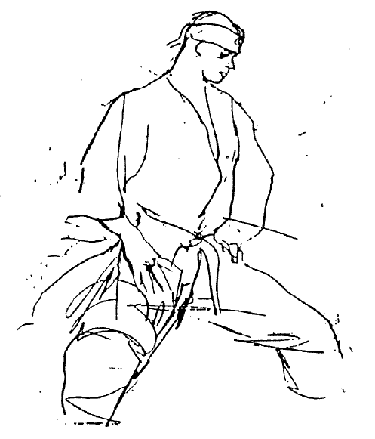

A BRIEF HISTORY OF SEISAN KATA
Okinawan legends reveal that the kata Seisan is named after the famous Chinese martial artist Seisan, who lived on the island of Okinawa during the sixteenth and seventeenth centuries. In those days, the Okinawans considered Seisan to be the Eighth Wonder of the World because of his unusual power and ability. Historical data indicates that the origin of the Seisan kata can be traced back as far as Soshu Matsumura in the nineteenth century, who was the instructor of Yasutune Itosu and Chōtoku Kyan.
Isshin-ryū Karate stems from two main streams. One method was developed by a village farmer, Yasutune Itosu and, since it was practiced in the city of Shuri, was named Shuri-te. Later the style was called Kobayashi-Ryū and today is commonly known as Shorin-ryū. The other method descended from the nobleman Kanryo Higaonna and was practiced in the city of Naha under the name of Naha-te. The modern version of Naha-te is called Goju-ryū (hard-soft method)
(OFFICIAL TIME 55.60s)
Seisan is the first kata that is taught to the beginner in the Isshin-ryū system. The kata is taught exactly in the same manner as practiced by Tatsuo Shimabuku who learned the kata Seisan from his instructor, Chōtoku Kyan.
The karateka encounters four phases when learning the kata.
1. ARA-KEZURI (Beginning) - this is the general education of the kata. In this phase, a karateka loses his fear of the unknown, of being unsure, and he is shown the proper direction. It is comparable to discovering a ladder against an object you have decided to scale. You start your climb up the ladder, grasping rung with one hand and then the other hand, one foot perching on the bottom rung, then the other foot. Similar to the basics of climbing, you progress one step at a time in the basics of Karate, breaking the kata into as many steps as you need to learn the form.
2. NAKA-KEZURI (Middle) - In this phase, the karateka sees that it is possible to climb while thinking about his progress. The techniques can now be compared to attaining the middle of the ladder or the middle of the climb. The karateka begins to feel confident in his ability, polishing what he has been practicing and developing an understanding of the techniques. Here he becomes more inquisitive.
In this stage of learning Karate, many hours are spent in front of a mirror as the student checks for proper stance, position of the blocks, the angles of punching, kicking and other moves. This period is particularly difficult because the student feels his training is becoming too routine.

3. HOSO-KEZURI (Top) – Now the student develops a desire for ultimate perfection and more knowledge. This phase is comparable to reaching the top rung of the ladder. The karateka now adds the kiai (loud, piercing yell) to the kata and is able to comprehend his progress. Because he has gained more self-confidence, the student project speed and power into each succeeding kata.
4. SHIAGE (Having Reached the Top) - In this final phase, the student realizes the result is worth the effort. He enjoys Karate for self-satisfaction and the long hours of vigorous training become a habit. The self-esteemed karateka then begins showing others how to effectively climb the ladder.
YOU CANNOT TEACH A MAN ANYTHING, YOU CAN ONLY HELP HIM FIND IT WITHIN HIMSELF
(Galileo 1564-1642)
During kata practice, you should exercise your mind as much as your body by constantly visualizing your imaginary opponents, thus performing kata as though you were placed in an actual fighting situation. Throughout the entire sequence of the Seisan kata, stress the use of your imagination and visualize the four opponents, their actions and reactions. You must be totally aware of all four adversaries, but being human, you must deal with them individually or, on occasion, two at a time. Furnish undivided attention to the opponents facing you, but be prepared to quickly change directions.
A kata is restricted only by a student’s lack of imagination. You must keep in mind that each kata technique may encompass a variety of target area and, when broken down individually, can be utilized in an actual self-defense situation. After you become more proficient, your kata can be performed with control against other students, enabling you to further understand the direct self-defense value.
An important element which constitutes overall kata ability is the “ki”. Ki is described as internal power, an inherent strength that can be applied in conjunction with an individual's physical strength. Since the ki is only developed through constant practice, a beginner should concentrate first on physical power. When delivering the techniques of the kata, apply your physical strength, concentrate your thoughts on the prescribed techniques, and exhale--emitting a sound as though you were pronouncing the word c-u-p. Through this consistent burst of energy, thought and sound, it is possible to acquire the use of one’s internal power.
I CAN FEEL THE POWER OF MY KI FLOW THROUGH MY BODY WHEN I PRACTICE MY KATA

SEIUCHIN KATA
Okinawan legends reveal that the kata Seiuchin is named after the famous Chinese martial artist Seiuchin, who lived during the fifteenth and sixteenth centuries. Seiuchin, being so powerful, could pierce the side of a cow with the tips of his fingers and penetrate into the body enough so that he could pull meat out from the inside with his powerful hands. Kanryo Higashionna who had gone to China and studied Karate is the party responsible for the contribution of the kata Seiuchin to not only Isshin-ryū Karate but also several other styles and systems.
Tatsuo Shimabuku learned the kata Seiuchin directly from Chojun Miyagi and gives credit to him for the profound influence of the Goju-ryū system into Isshin-ryū Karate.
(OFFICIAL TIME 45.50s)
NAIHANCHI KATA
Naihanchi kata comes from Kung-Fu origin and most of us know or have talked to someone in other styles of Karate and they have several Naihanchi’s in theirs. As for the kata of Naihanchi, the originator is still unknown, yet these kata were known to the Shuri and Tomari schools.
The most important and significant distinction of Naihanchi lies not in developing fighting skills of offense and defense, but in training the lower part of the body such as the waist and legs through slow and steady sideward movements with maximum strength, and also in building up those muscles indispensable to Karate training.
The posture for Naihanchi is much similar to the sitting position for Zen - pulling back the waist and sitting upright with the shoulders down and chin drawn, with strength concentrated on the abdomen.
This kata is often called “Kibadachi” or “Tekki" which means "horse riding straddle,” in mainland Japan. However, nothing but the term Naihanchi has been traditional among Karatemen in Okinawa.
(OFFICIAL TIME 35.40s)
WANSU KATA
This kata is the fourth in the Isshin-ryū system. It is a power kata that is performed in an "X" pattern. The movements are forwards, back, left, right and forward again.
Wansu comes from Shorin-ryū and is one of Isshin-ryū’s most copied forms. It is said that this kata was brought into Okinawa in 1683 by a Chinese envoy named Wansu and then reformed and then developed later by Karatemen around Tomari Village. The kata was named after the envoy. The hidden fist punch is the most significant technique adopted in Wansu.
(OFFICIAL TIME 45.50s)
CHINTO KATA
Chinto - the tiger of Chinese Karate comes, from Shorin-ryū and has one of the most vivid backgrounds of any of kata in Karate. It is characterized by dynamic movements using kicking techniques including the flying kick and unitary techniques of offense and defense. The kata is simply done through a straight line. This was also a favorite of Kyan and Arakaki.
There is a legend that states Karate first came to Okinawa in the thirteenth century when Chinto, a shipwrecked Chinese sailor, was washed ashore. Naked and penniless in a strange country, he hid in caves by day and at night would sneak into the villages to steal food for survival. The villagers complained to the king, who sent his best samurai, Matsumura, to capture the sailor.
Matsumura tracked Chinto to the cave where he was living; he confronted Chinto. When the sailor refused to surrender, the samurai tried to overcome him by force. Chinto blocked every technique Matsumura threw. The sailor then hid in a nearby cemetery.
Matsumura returned to the king and reported that there would be no more trouble from this man. Then he went back and befriended Chinto, who in turn, taught him his system, including the kata now known as Chinto.
Chōtoku Kyan, incorporated Chinto kata into the Shorin-ryū system. Kyan was the first Sensei of Tatsuo Shimabuku who was Okinawa’s leading Karate master.
(OFFICIAL TIME 45.50s)
KUSANKU KATA
Kusanku - another kata from Shorin-ryū - is like Sunsu, where one person is surrounded by 8 people and is really for the small person and has the speed movements for himself. In history on Okinawa there was the big fight of the time between Kusanku and Naihanchi. In the contest, Kusanku threw Naihanchi to the ground but as he did, Naihanchi hit Kusanku in the elbow and there was no point. Much on the order of today’s tournaments where there is a clash and no point is awarded.
This kata was adapted and developed by Okinawan Karatemen after it was brought into Okinawa in 1761 by a Chinese karateman named Kusanku. Kusanku is the most magnificent and advanced kata of all Matsubayashi-Ryū Karate. Most of the advance techniques of offense and defense appear in the Kusanku, the longest and most difficult kata, requiring painstaking practice of more than a decade for mastery. It was the favorite kata of Kyan, who learned it from the karateman Yara.
(OFFICIAL TIME 60.65s)

SUNSU KATA
Sunsu - Isshin-ryū's own Sunsu, which is named after Master Shimabuku, consists of combinations of movements from the movements from the first six katas. It is a difficult kata to perform; that is, with any degree of strength, speed and accuracy. Sunsu, Master Shimabuku is nickname means "Strong Man”.
(OFFICIAL TIME 60.62s)
SANCHIN KATA
Sanchin – comes from Goju-ryū and is that styles basic kata. The oldest kata by far still practiced in modern Karate, Sanchin is a treasury of dynamic body tension and controlled breathing so complex that scarcely a handful of karateka, after a decade of study, will begin to understand it. Fewer still can claim to have ever mastered all of the intricacies and mysteries of Sanchin.
"Three steps" or "three conflicts,” as Sanchin is best translated, traces its origin back to China's later T’ang dynasty, where a revolutionary sort of self-defense, nurtured in militant Buddhist temples, was fast establishing itself as the dominant force in that land’s martial arts. Specific patterns of breathing were incorporated, taken from the Taoist exercise regimens, to facilitate the shift from rigid to relaxed and vice versa.
In 1857, Kanryo Higaonna came to learn the Sanchin Kata, which at that time was known as "k'ingai". With some minor variations - the spear hand became fists and the circular blocks were modified - the kata is now known as Sanchin.
KUSANKU-SAI
Kusanku-Sai - almost the same as Kusanku except that you are armed with three sai. The third one is a spare if you should happen to drop one but as you know in the last part of the kata you throw one sai pinning your opponent’s feet to the deck.
TOKUMINE NO KUN
Tokumine No Kun was the creator of the Bo approximately 300 years ago. The bo was practiced on the left side of the body or from a left sided stance, until Sōke made the changes to the right side of the body. It was Shimabuku's favorite bo kata.
CHATAN YARA NO SAI
Sōke related the story of a Budo expert by the name of Controu. Mr. Yara had a big fight with Mr. Combra Yama who was armed with a sword. Mr. Yara during the course of the fight ran into the fort and acted like he was going to hide from Combra Yama but at an opportune moment jumped out on him and cut Combra Yama’s right arm. Thus the fight was ended. Since that time, Mr. Yara has become famous for his ability with the sai and the kata Chatan Yara No Sai is appropriately named.
BO SHI SHI NO KUN NO DAI
The creator was Shi Shi No Sekata - very famous Karate man, as said in the history of Isshin-ryū Karate, Sōke has fought with the 13th generation of Shi Shi No Sekata.
URASHI NO KUN
In the Urashi Bo you should show the front of the bo to the opponent but use the back hand strike in this one often. There was the big fight on Okinawa between Matsumura and Huntagawa (who is responsible for Urashi Bo). Matsumura threw Huntagawa with the bo with a groin throw, but Huntagawa was so fast that the people watching did not realize that Huntagawa killed Matsumura the instant that he was thrown. Just think what most of the people were doing or thinking that Huntagawu was through until they realized that Matsumura was dead.

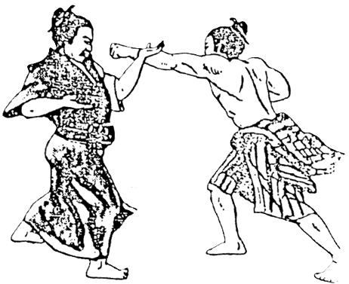
Okinawa-te
KUMITE--PRACTICE FIGHTING
The life of Karate is formal practice fighting (kumite), without which Karate is no more than a game for one person. Practice fighting is essential for the attainment of strength and skill.
Formal practice fighting is a mutual exchange of techniques. A great deal of practice is necessary in it to cultivate and to improve the speed of the eyes, hands, and feet. This type of work is genuinely useful and proves itself in actual combat. Neglecting this practice indicates a lack of understanding of the Karate spirit.
To become proficient in formal practice fighting a thorough background and a great deal of practice in such basic techniques as the thrusts, strikes, and blocks are essential. The basic techniques in series make up the Karate formal exercises, which in turn are the building blocks of practice fighting.
As the word suggests, practice fighting (kumite) in Karate is a method of practicing the various techniques while facing an actual opponent. In its early days the main forms of Karate practice were the formal exercises (kata) and except for occasional tests of strength of the various punches, kicks, and blocks there was no sparring as such.
In developing kumite, seriously consider the following seven essential conditions:
1. To develop techniques to enable us to defend and attack
simultaneously.
2. To develop techniques to enable us to defend and attack
simultaneously using both hands.
3. To develop techniques to enable us to defend and attack
simultaneously using both hands and feet.
4. To develop techniques to enable us to shift the body to
the attacking position reflexively and naturally in order
to always keep beside the opponent and avoid facing him.
5. To develop techniques to enable us to defend and attack by
means of shifting the body and approaching the opponent
from the side or front, with definite determination to
find some way of beating the opponent, in critical
situation.
6. To develop swift, reflexive nerves or senses which enable
us to kick the opponent when he catches us or when we
catch him.
7. To develop techniques to enable us to attack the opponent
by kick or blow, reflexively, after we have suppressed his
movement without losing our grasp on him.
Kumite is the application of the above conditions. Prearranged kumite must be practiced as a life-or-death match, but never with the intention of harming the fellow practitioner. In kumite you must commit yourself totally, and from this commitment arises the realization that your blow could easily kill your opponent, that the karateman holds life and death in his hands. You must never engage in kumite with the intent to
kill. The realization that you hold life and death in your hands should lead you to the reaffirmation of life-your own and your opponent’s.
Kumite is a unique act of sharing, for with your opponent you are reaching out together toward the total commitment of self and toward the understanding of that commitment. Both of you are striving to exert to the maximum human capacity and to test each other to the fullest. When two people practicing kumite are striving together toward total commitment, a mutual relationship is established in which perfect communication becomes possible even though not a word is spoken. From this striving can come the realization that you have committed yourself and the understanding of that commitment. Most of all, it is an experience of human warmth in which karate grows to be karate-do (way of life).
ATTACKS
There are moves that will give you some ideas of how to press an opening attack, as well as how to deal with an opponent who specializes in doing the unexpected. The key here is practice, a constant repetition that will improve your timing and most important of all, render your attacks reflexive. If practiced properly, you will not need to think during a match, but simply act and react.
One of the most important movements in every kumite match is the initial move. It can be either a fake or an actual attack. Using the fake (feint) will generally tell you a great deal about your opponent, whether he is a retreater, a counterman or a sitter. The fake can also be used to set up your opponent for an attack, the timing of which is equally as important as the fake. If these gambits are correctly used, you will find a new edge to your attack, and a much higher point average in your matches.
THE INITIAL MOVE
One of the most difficult things about Karate free-sparring is getting inside your opponent's defenses with your attacks. You should make use of your initial move to bring about a reaction from your opponent, and then counter-react to it. Your opponent's reaction will dictate your own way of attack. There are many factors involved. One is your personality aggression level.
A passive personality will usually hesitate to attack. The very aggressive personality has a different problem. Overly aggressive persons are often disqualified for unnecessary roughness or lack of control.
Another factor of judgement in your initial move is the personality of your opponent. Is he a retreater or a counter attacker? Finding out what type of fighter he is, you should make adjustments in your own attack. For instance, if you charge an opponent with a good set of combinations, you will be blown out of the ring if you are not careful. If you employ a like attack on a retreater, he will be halfway into the grandstands by the time your kick is in mid-air. The main point is to know what your opponent is going to do when you attack – BEFORE YOU ATTACK!

CLOSING THE GAP
The single most important phase of making the initial move is closing the gap, which separates you and your opponent. It is an art form which often separates the good fighter from the mediocre one. If your opponent is the type of fighter who stands his ground and does not retreat with your every movement, certain closing moves will help you in gaining the points you want at the start of the match. If your opponent is a retreater, you may do one of two things. You may have an attacking opener which works from a distance, or you may sit him out and have a strong counter set for him when he charges. Be careful not to be lulled into confidence by a man who prefers setting a large distance between the two of you, for a good fighter can make a devastating attack from a distance.
The ideal situation would be to train yourself for an expertise in distance attacks, one move attacks and counterattacks.
One of the most effective ways that you can conceal your intent to close the gap between you and your opponent, is to be in constant motion. The man who takes a rigid "Rock of Gibraltar" stance will not be able to deceive anyone when he finally decides to launch forward. Attacks from such a stationary posture have all the surprise of a wall that suddenly moves. In order to catch your opponent off-guard with your attacks, you must be in constant motion. You must be loose, with your weight on the balls of your feet--ready to move in any direction to block, strike or counterattack. This is not to say that you should be running all over the ring, but confine your constant motion to a boxer's bounce, side-stepping, moving back and forward and generally keeping your opponent constantly off-guard.
When you finally do close the cap, never do so without employing or planning to employ an attacking maneuver.
THE LUNGE
The lunge is a relatively short-range technique, usually between 8 and 12 inches in length along the floor. It is one of the fastest ways in which you can close the gap, and also one of the most powerful. The lunge can be initiated from a variety of stances successfully. It is most effectively employed from the fighting stance, which closely resembles the classical Karate forward stance, though not quite so deep or stationary.

Once you have committed your mind to launching a lunge attack, be sure you do not telegraph your intentions by bobbing or leaning. The lunge should be a single, smooth motion without the jerking and leaning forward which would apprise your opponent of your intentions.
THE SHUFFLE
The shuffle is an excellent means by which to close the gap between you and your opponent because, if done correctly, it will give you the advantage of surprise. Keeping in mind that you should be in constant motion, the initial part of the shuffle move, which is the slide-up, will not telegraph your intention to press an attack. The best opener in your attacking combination from the shuffle, would usually be a reverse punch, which should be smoothly begun during the slide-up and make contact as you complete the step. The step and punch should always land together.
THE STEP-THROUGH
As an attacking opener, the step-through technique provides great potential for power as well as a means by which to cover a little over two feet of distance between yourself and your opponent. This type of attack maneuver is very difficult to counter or escape without being pointed because it is a natural maneuver that allows you to keep maximum balance. When used with the fill in the gap policy of throwing a battery of punches while taking the step, it can have a bewildering effect on your opponent.
THE SLIDE-UP LUNGE
The slide-up lunge or crossover maneuver is effective as an attacking opener when you and your opponent are separated by a gap of up to five feet. If practiced properly, it will allow you to close a wide gap without having telegraphed your intentions to your opponent. The slide-up or crossover portion of the move in particular can go wholly unnoticed by your opponent, leaving him unprepared for the lunge that is to follow.
THE STEP-THOUGH LUNGE
The step-through lunge is also useful in closing a large gap between yourself and your opponent. This technique is effective anywhere between 18 inches and five feet, and is difficult to counter. Opponents are often lulled into believing that it will cover much less distance than it actually does, since the opening motion appears to be a single step.

ATTACKING TECHNIQUES
Attacking techniques are of great value in chasing down a "running" opponent and scoring on him. The emphasis must be placed on supreme technical excellence and total aggressiveness of attack. The moves, making up a series of your own attacking techniques, using those strikes and kicks which you feel are best suited to your style of attack, are geared toward giving you the ability and sophistication to attack with finesse and power. Making the techniques spontaneous and without forethought. In other words, they should become automatic to you.
SHAPE THE RING
In matching, is the shape of the ring the same throughout the match? Yes and no. Yes, the dimensions of the ring remain constant, but either you or your opponent shapes the space on which the match takes place. Make him fight your fight by dictating the direction and the distance on both offense and defense. Move him to where he leaves a space open in trying to hit you (defense). In a match, you are following your opponent or he is following you.
You can shape the ring in three ways, depending on how you want to structure the match to fit your strategy and tactics:
= Triangles = Squares = Circles

During the match, you may try to confuse your opponent by reshaping the ring. For example, you could begin by simply attacking and withdrawing along the lines of a square, either up and down the ring or from side to side.

Then change the situation to a triangle to corner him and hopefully catch him with one foot out of the ring where you can score but he cannot.

Or to a circle in order to avoid his attack or to off-balance him.

To further upset your opponent’s strategy, you can raise or lower your stance, thus changing the height of his target (you) as you move in squares, circles, and triangles to score.
COUNTERATTACKS
Mastering the techniques of counterattack can make you a winner in any encounter. Offense and defense are both important when free-sparring, but counterattack is more important. It can cause more accidents to opponents, and it takes offense off the opponent’s mind.
Anticipate your opponent’s open spots, and attack accordingly. Timing is necessary to take advantage of your opponent’s momentum, and the inability to avoid your counter-attack.
Always counterattack by the shortest distance possible, after avoiding your opponent's attack in the shortest distance possible. It is most important to keep your eyes on the opponent at all times. Never turn your head away from the opponent. For example: Your opponent executes one attacking technique at you. If you only avoid his attack, then he has another chance to attack, but if you avoid it, and counterattack, at the same time, then your opponent has little chance to avoid your attack because he is still moving toward you. After several months of constant practice, you can develop good counterattack techniques.
One should practice body movements with a mind for defense. All animals, including man, have unconscious reflexive movements; instinct. Fierce, strong animals, when attacked, move and avoid the attacker. Weaker animals, when attacked and cornered, counterattack instinctively. Counterattack techniques teach the mind to react calmly in an emergency. Normally, people never think about attacking or fighting. Therefore, in an emergency situation, they do not know the necessary movements to avoid and counterattack. Unconsciously they try to move away giving the opponent another chance to attack.
Most students never consider the techniques of counterattack. They never practice counterattack techniques. They concentrate solely on practicing and developing their free sparring techniques. When free sparring against a more accomplished martial artist, the student tends to be intimidated; he has no self-confidence. Students should make it a policy of counterattacking so that he will automatically respond with counterattack techniques - to his advantage. Each technique should be practiced slowly to develop speed, power, and timing. The key to mastering counterattack is PRACTICE. Most important is that they should always be used without fear, and for good and useful purposes. Remember counterattack is better than running away.
ZONES
- Opponent can neither kick or punch you
- Opponent can kick you (kicking zone)
- Opponent can punch you (punching zone)
- Opponent can grapple with you (elbow and knee zone)

REQUIREMENTS FOR PROMOTION TO GREEN BELT

1. Name 10 vital points of the body
2. Explain the importance of stretching
3. Explain the importance of the basic fundamentals in Karate
techniques
4. Know the history and origin of Karate as well as important
events in Karate
5. Know the features of Isshin-ryū Karate
6. Four months as a YELLOW BELT or at least 32 class attendance
7. Write a one page paper on KATA
8. Know the Code of Karate and Creed of Karate and explain in
detail its meaning
9. Perform Seiuchin and Naihanchi satisfactory – explanation of
each movement and its history

RESPECT FOR SENSEI

The term “SENSEI” is the most commonly used of all honorific titles. Basically it conveys the meaning of “teacher” or “instructor”, but underlying this is a title embodying deep honor and respect. In a traditional Dojo, the Sensei is always the master instructor to whom the highest respect is due. He is associated with the centuries long chain of great masters and their knowledge and teaching of Karate. Thus, respect for the Sensei includes not only respect for the masters of past decades but also to the art of Karate. In terms of etiquette the Sensei should be treated with the respect listed below.
1. When the Sensei enters the training hall, the highest ranking member, or member in charge should immediately recognize his presence and authority by calling the training class to attention and offering due respect by bowing.
2. At all times when addressing or referring to the head instructor, the student should use the title “SENSEI” and avoid using the instructor's proper name. To do otherwise is considered as an insult.
3. Should a student desire to inquire about anything during training class, he must obtain permission through a member senior to himself, a chain of rank and command should be formed and never broken for any reason. It is considered a breach of etiquette to approach the Sensei directly.
4. Above all else, the student should seek to uphold the ethics and integrity of the Sensei, and strive to remain loyal to him and the art of Karate.

THE MARTIAL ARTS
JIU JITSU
The oldest of the Japanese Military Arts is Jiu Jitsu, a form of self-defense using disabling kicks or blows to vital areas; locks or grips to immobilize an opponent or to cause dislocation or fracture; strangulations; pushes, pulls and throws. Throughout the long and dramatic reign of the Samurai, schools of Jiu Jitsu flourished all over Japan. The numerous sects zealously guarded and transmitted their own special secrets. Today Jiu Jitsu survives in certain forms and to some extent in Judo and Aikido, and even in Sumo.
The Japanese, in the 12th century, adopted it from the Chinese. It was used by the Samuri, whose sole purpose in life was to fight for their lord. Jiu Jitsu was at its peak in the 17th and 18th centuries. The masters seldom put their methods on paper, their techniques were passed onto their pupils, the best of whom in turn opened their own schools. Two of the great masters were Jigoro Kano and Morihei Uyeshiba.
JUDO
The most widely known successor of Jiu Jitsu is Judo, the creation of Dr. Jigoro Kano who opened the first School of Kodakan Judo in 1882 in Tokyo. His purpose was to preserve and make available in modern sport from all the valuable physical training, mental conditioning and cultural benefits of Jiu Jitsu. It includes many techniques that give a smaller opponent an advantage over a larger, stronger one.
In formulation of Judo, Dr. Kano incorporated the scientific principles of Jiu Jitsu, but eliminated techniques which could cause injuries and established at the ultimate goal for all players the ideal of “Mutual Welfare of the Mind and Spirit,” as well as that of the body.
AIKIDO
One of the surviving forms of Jiu Jitsu is Aikido, the modernized system of Jiu Jitsu. Aikido is self-defense based on techniques of Atemi, attacking vital points using fists of feet as weapons and “Kansetsu,” throwing or applying a submission hold by twisting joints, usually the wrist. It is never the purpose of Aikido to inflict injury, but merely to control an opponent's attack in the most efficient and least traumatic manner. Students of Aikido do not engage in randori (free sparring) or competition, but learn a large number of pre-arranged forms of self-defense. AIKIDO IS THE ART OF CIRCLES.
Morihei Uyeshiba began developing Aikido around 1900. He had sought a way of life which would strengthen body and mind, and provide a path for spiritual peace. When he discovered Aikido, he professed to have found enlightenment and communication with the universe.

SUMO WRESTLING
Little known in the United States, Sumo has a long history in Japan. Even before the 8th century there was mention of exhibitions of Sumo, a form of wrestling in which two athletes contended to see which one first force the other to touch the ground with any part of his body other than his feet or to step outside the small circular contest area. It is Japan’s leading national sport and the grand champions are figures of National Importance.
KEMPO
Kempo, the fist way, comes from the old way of brawling, but with more techniques and precision. It looks like a combination of wrestling and boxing.
Kempo’s origin is rooted within the old Jiu Jitsu school. Some schools taught the special weapons techniques of Yawara for self-defense, others preferred Tai-Jitsu with its grappling and throwing forms, or Kempo which stresses punching, striking and kicking techniques.
During the latter part of the 16th century, the Kempo aspect of Jiu Jitsu had become formalized into a distinct system of self-defense, employing both hand and weapons techniques. Today, Kempo, like its sister arts, is a sport, a physical exercise, and a means of self-defense.
KUNG FU
For many years the Chinese fighting systems were the property of secret societies, and as long as survival depended on the mastery of weapons and such, little was known about them outside the Chinese community. Now the art is available to anyone who really wants to learn, but very little is known about the origins of Kung Fu.
Kung Fu uses circular blocks and many techniques of gripping, clawing and gouging of the eyes, ears, nose-mouth, rectum, intestines and groin. The movements of Kung Fu still resemble the movements of animals. The horse position is the foundation on which Kung Fu is built. Like the old Chinese cavalry, the Kung Fu man goes into battle on his horse and uses it in somewhat the same way. Unlike the Karate man with his flying kicks, the Kung Fu man stays close to the ground, and his movements are more natural looking, not as stylized as Karate. The idea is that a punch delivered upward with the full power behind it of the coiled body springing upward from the ground is more devastating than a blow swung from a standing position. Some Kung Fu maneuvers are designed to develop the grace, litheness, and agility necessary for endurance and correct delivery of attack in a fight. Just as Karate has its prearranged katas, Kung Fu has its prearranged sets called mu-gung-fu. Some of these can be performed in a large telephone booth, others would need a space as big as a football field. The different styles stress the different elements of unarmed Kung Fu fighting: Tsei, for instance consists of kicking and side punches; Li, of slaps and poking techniques against vitals; Mawk, blocking; Hung, power punching; Fut, the sword hand.

HISTORY OF THE BO
As with many weapons of ancient heritage, the exact origin of the bo (kon or straight staff) is obscure. Anthropologists know that is was among the first tools used by early man to help him survive. Initially, it took a form of a stick, a branch from a tree or a club and was used both to defend against attackers and to help acquire food. Over the ages, the use of a bo as a weapon has been developed and refined. Still, because modern practitioners hesitate over the exact details of its evolution, several theories on the history of the bo, as it is known today, prevail.
Whether factual or not, one very popular theory provides the following rendition of this history: Around 517 A.D., the Zen Buddhist priest Daruma Daishi, the leader of the Shorin-Ji Temple in China, brought into the effect fluent use of the bo. During this period in Chinese history, government control was minimal and law and order belonged only to those capable of securing it for themselves. For Daruma and his disciples, proficiency in the martial arts and the use of weapons such as the spear, the sai, and the bo provided the only feasible means of protecting their temple. The bo-jitsu techniques Daruma ordered his disciples to master and perfect greatly influenced the later developed Ryūkyu Kobu-Do.
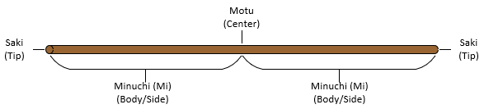
Ryūkyu Kobu-Do, the Okinawan art of using Karate weapons such as the bo, the sai, the kama (sickle) and the nunchaku first gained prominence around 1314 A.D. when the Japanese government passed two laws which deeply outraged the people of Okinawa. First, it barred all the inhabitants of the island from owning or possessing any sort of lethal weapon. Second, it imposed on them a monumental increase in taxes. Deprived of any conventional means of physical protest or retaliation, the people turned not only to empty-handed martial arts forms for protection, but to their farm implementations as well, using them as weapons which eventually become the tonfa, the nunchaku, the kama, the kai (boat oar) and the bo. The bo itself originated with the tenbin, a stick held across the shoulders, usually with buckets hanging from each end, that was used to convey food, water or some such. When the need arose, the tenbin, or the bo as it is known today, was manipulated to strike or block in techniques either based on or very similar to those used by Daruma and his disciples.
HISTORY OF THE SAI
During the Japanese occupation of Okinawa, the invading warlords prohibited the use of ordinary weapons. So the Okinawans turned to Karate and Kobu-Do (the use of weapons such as the bo, a staff; nunchaku, two hardwood sticks securely connected by rope or chain; kama, a sickle; and surushin, a length of rope with weights attached to both ends) for protection. For instance, the sai (short sword) was dragged through the soil by one peasant, while another would plant seed in the resulting furrow. If approached by a marauding samurai, the sai doubled as a weapon with which the peasant could counter a sword attack. Usually the peasant employed two sai, one for each hand, and concealed a third inside his obi (belt), which even a proficient sai artist may have found cumbersome when engaging in battle with a talented swordsman. Thus the third sai was actually used to throw at the warrior. This maneuver was often the key to winning the encounter.
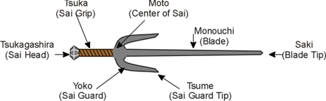
The sai originally was capable of killing or maiming an enemy with a blow to the back of the neck or a thrust to the throat or the eyes. However, the sharp points of that first sai have been blunted and rounded. It no longer serves as a weapon for mortal combat. Fashioned of steel and chrome-plated, it is a more attractive instrument bearing two prongs at the handle.
When first introduced to Japan, the sai was called jutte. It bore a single prong at the handle. The Japanese police found it quite effective in blocking the thrusts of the samurai. The sai was also used against pressure points when making arrests. Japanese Karate practitioners at that time accorded the instrument a rather cool reception. Very few found it interesting enough to try, but once they did, they were fascinated with it.
Americans became increasingly aware of the sai when karateka flashed it during kata competition at tournaments. They promptly recognized it as a valuable instrument for developing poise and posture, so essential to good Karate.
Rigid training and skill are required to manipulate the sai in techniques which parallel the movements of Karate. Practitioners of the sai develop excellent flexibility in the use of their hands and can often handle the instrument with the dexterity of a majorette twirling a baton.

STANCES IN ISSHIN-RYŪ KARATE
The stances in Isshin-ryū Karate are short, natural stances enabling you to move quickly but with power. The stances you use will very due to your opponent, plan of attack, and your physical characteristics. The stance you are in, make sure you are in balance, be able to shift to another stance. Above all, never lean forward, keep your body straight and never look down. The stances should be automatic so that you can keep your eyes on your opponent.
NORMAL STANCE (Informal Attention)

This stance, with toes pointed straight ahead and with both legs straight, is infrequently used in actual combat, but is of importance in spiritual unification when we stand with one hand folded on the other at our abdomen and meditate or when we breathe between one kata and another. It is a natural body position.
OPEN-TOES STANCE (Informal Attention: toes turned out)
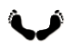
This natural relaxed stance resembles the stable stance, except that in this case, put your heels together. Though this stance is not used in actual fighting, it is the first and last step in all the katas.

NATURAL STANCE (Open-leg stance) SEIUCHIN STANCE
This in the most natural of all Karate stances. It is the basis for all other stances. When taking this stance, one should be in complete harmony with nature and with the universe. All tension must be eliminated – relaxed. From this position, you must be able to vary your stance according to changes in your opponent's stance.
NAIHANCHI STANCE (Pigeon-toe or inverted open-leg stance)

With your body in a natural posture and your feet spread about shoulder width, turn your toes in, and bend your knees slightly inward. This position permits quick agile movement and helps develop the muscles of the lower half of the body. Weight equally distributed. In a stationary position, the body is locked from the waist down and relaxed from the waist up.
It is designed for movements sideways when your back is to a wall with opponents to your front and on both sides of you; exposes only your sides to opponents approaching from the sides. The front of the body is open as a target. The movement is limited to side movements.

PARALLEL Stance

This also is a natural stance, but one in which we stand with our feet about shoulder width apart and our toes pointed straight ahead. We use the parallel open stance more in formal exercises than in combat, but we must pay particular attention to stances of this sort because they keep the body in constant preparedness for attacks from any quarter. Always maintain one of these postures, and you will always be ready. Beginners should be extremely aware of the importance of these stances.
CAT STANCE (T Stance)

This is a good speed stance used preferably to stop an opponent’s attack. It is good for moving in most directions. From the rear leaning stance, turn the toes of your forward foot out slightly, and pull that foot in a little. Distribute your body weight 90 on the rear foot and 10% on the forward foot. Let only the toes of the forward foot touch the floor. Be careful that you neither bend your rear knee too much nor lower your hips too much. Keep that leg bent only enough that you can always use it easily. Always keep your body weight on a straight line.
FRONT STANCE (Forward Leaning Stance)

This stance is for a powerful punch or kick preferably a lunge punch or thrust kick. Put one foot out in front or the other so that the two are about the distance of the width of your hips apart. Point the toes of the forward foot straight ahead, bend the knee, lower the hips, and keep your body's center of gravity low. Point the toes of your rear foot slightly outward. All of the weight of your upper body should rest on your hips, and the straight line of your center of gravity should fall slightly forward of an imaginary spot in the dead middle of the distance between your legs.
SEISAN STANCE
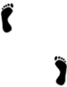
The feet are shoulder width apart, weight equally distributed, with the toe of the trailing foot even with the heel of the lead foot and the knee slightly bent. It is a strong offensive stance because you have both hands and both feet in front of your opponent. It is not a good defensive stance because your front is open to your opponent, exposing vital areas of your body.
SANCHIN STANCE
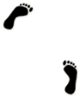
Spread your feet about shoulders’ width apart. Put the toes of your rear foot and the heel of your forward foot on a straight line running sideways to your body. Point the toes of both feet about 45 degrees inward. Bend both knees inward slightly, and lightly lower your hips. Keep your upper body straight in such a way that your body’s line of gravity falls at an imaginary spot right between your feet. In this stance your body is strongly balanced and you are free to move in any direction to perform easily all of the kicks and thrusts. To make the stance "rooted” (semi-stationary) stance: grip the floor with the feet by digging the heels in and pushing the balls of the feet to the outside, locking the hips. Raise the fists to the front of the face, bring the elbows back down to the rib cage, and exhale, locking the body from the waist up.
This stance is used primarily in practicing breath and muscle control, as in the Sanchin Kata. It is seldom used in matching or in self-defense because of the time it takes to shift to other stances. It will help you develop an extremely strong diaphragm.

MAKIWARA
Students should start working real slow and gradually build both repetitions and power. Here are some recommended techniques:
From a Seisan stance, place yourself so that your fist will extend one to two inches beyond the board. Techniques are snap punch, rotating punch, downward chop, and forearm smash. From a Seiuchin stance use backfist, outside chop, inside chop and ridge hand. You can also practice palm heel and gouges on the Makiwara, but a heavy bag would be more preferable.
Train unwisely, try to show off, try to rush the process and you can injure yourself, or in later years, you could suffer from calcium deposits, bone chips, damaged joints, or poor circulation.
The board will help you develop distancing as you practice your various techniques. You should stand so that the weapon penetrates one to two inches beyond the makiwara board. Some boards are more flexible than others, so use a little common sense. It is better for the board to be too springy than too stiff. Timing in focus of power, in your technique and in relaxing and tightening of muscles is a benefit of the makiwara. You want to be relaxed when the technique starts, gradually tightening until you are fully focused at completion of the technique. Then relax and you are ready to start another technique, but it also conserves energy as well as develops speed of technique. Concentration is improved. Control of technique is improved as you hit the exact spot with the exact power that you intend. Power is improved because of the many repetitions of technique. Coordination is developed. You are learning when to bring each muscle group into play. As technique and ability develop your confidence grows by leaps and bounds. Self-discipline is certainly not least of the benefits of the makiwara. You have forced yourself to work on the boards and to follow the rules even when you didn’t want to. This is self-discipline.
In a short time, students will be able to see just what a valuable piece of equipment that Makiwara board is if it is used correctly. If used incorrectly you could be nursing sore aching joints on these cold wet winter days and nights instead of skating, sleighing or whatever.

THE GOLDEN RULES OF KARATE
In Karate, start with a bow and finish with a bow. Do not forget the spirit of a bow in daily life, as well:
No initiative attack in Karate. Do not initiate a fight; this refers to mind rather than techniques.
Karate is great assistance to justice. Challenge injustice in your community and in the world.
Know yourself at first and then others. It is extremely difficult to know oneself, but, nonetheless, you must examine yourself as often as you can, and at the same time judge others intelligently.
Spirit first; techniques second. The right spirit develops good techniques.
Be ready to release mind. A mobile mind - open, flexible and calm.
Accidents come out of idleness. Be cautious even in relaxation.
Do not think that you can learn Karate only in Dojo. Karate-ize daily life. Never forget the spirit of respect for people.
It will take your entire life to learn Karate. Practice as long as you live. You will continually be improving spirit as well as techniques.
Karatenize everything. Karate alone is not Karate. Apply the spirit of Karate to everything in life, and you will find a deeper Karate.
Karate is just like hot water. If you do not give it heat constantly, it will again become cold water. Unless you keep training, your technique will deteriorate.
Do not think you have to win. Think, rather, that you do not have to lose. If you think that you have to win, you will be tense and therefore will lose. On the other hand, if you have confidence that you will not lose, you will be relaxed and flexible, and in this condition will have a much better chance of winning.
Victory depends on your ability to tell vulnerable points from invulnerable ones. Attack only vulnerable parts. And always appreciate the fact that in even one second your opponent might sway from a position of strength to one of vulnerability.
Move according to your opponent. Be flexible and have good Karate eyes.

Consider your opponent’s hands and legs sharp swords. Make a habit of suspecting that your opponent has a sharper and faster sword than you, so that you will always be cautious.
As soon as you leave home for work or school, think that millions of opponents are waiting for you. Be ready at all times.
Low stance for beginners; natural stance for advanced students. Take as low a stance as possible in order to build up muscles and to stabilize the stance. After you get a black belt, you can take as high a stance as you want, if you can prove that your high stance is better and more effective.
Practicing a KATA is one thing and engaging in a real fight is another. Perform a KATA correctly and be loyal to basic techniques. In a fight, however, you have to be more flexible, taking into account your opponent's position, distance, ground, etc.
Do not forget strength and weakness of power, bending down and stretching up of body, and slowness as and speed of techniques. POWER - SPEED – TIMING Be flexible and do not use energy unnecessarily.
Devise at all times. If you punch twenty times, each of those punches is quite different. Repeat the same technique until you can punch as you want to. Unless you advance every day, you are doomed to retreat.
Never start a fight. Wait for your opponent’s attack.
Stay away from unnecessary trouble. Never jump into a meaningless fight. If you practice these principles, your attack will not appear to be an attack, but look instead like a block.
Never under-rate your opponent no matter how weak he may look. The moment you look down on him, you are doomed to death. Anyone who does not abide by this rule is not qualified to learn Karate.
You must be serious in training. Your opponent must always be present in your mind, whether you sit, or stand, or walk, or raise your arms.

REQUIREMENTS FOR PROMOTION TO PURPLE BELT
1. Explain in detail the importance in performing a kata and its purpose
2. Stances in Isshin-ryū Karate and its meaning
3. The four phases when learning the kata
4. Must be a member of the AMERICAN OKINAWAN KARATE ASSOCIATION
5. Explain the purpose of the makiwara board
6, Name 20 vital points of the body
7. Name 10 pressure points of the body
8. Write a one-page paper on “What Karate means to me"
9. Demonstrate various blocking techniques: hard and soft
10. Perform Wansu Kata satisfactory and explanation of each movement
11. Four months as a GREEN BELT or at least 32 class attendance

KI - THE MYSTERIOUS ENERGY
The term KI has several meanings. The term means “Life Energy,” sometimes “Air,” which is a way to collect and expend the energy. To the ancient Chinese, the universe is basic energy (Tao) and a perpetual interaction of energy opposites - YIN and YANG. Night and day, hot and cold, are examples of such universal opposites that interact with each other constantly. The body is a Yin-Yang structure composed of twelve basic organs, fourteen meridians, and 700 points, some which transform but do not retain energy (Yang) and some which store but do not transmit energy (Yin). The energy flowing through the body flows in certain directions to certain points, depending on stress; the more need or stress, the greater the distance of energy. Thus, a person has all the energy he needs; it is just a matter of stress and focus on the handling of the stress. The reason why the energy is not properly used to great benefit is because our consciousness demands reassurance that all is well. Therefore, energy is expended in distorting stimuli and repressing other stimuli. The repression results in the consciousness imposing limitations on what a person thinks he can do. The consciousness also causes an energy malfunction by acting as a brake, a checkpoint, delaying the mind’s intention and the body's response to that intention.
The question becomes: How do you tap this energy or KI and make it work effectively for you? According to the ancient Oriental masters, the energy is stored in the stomach about two inches below your navel. This point is both your physical and emotional base: it is the center of your body's gravity, and it is also the center of your emotional reactions. Have you ever been sick at your stomach due to emotional stress? The force of the waist and the abdominal area coordinates all parts of the body, connecting the upper and lower parts of the body and benefiting the nervous system. The largest muscles of the body are located in this area. About one-third of your body weight is concentrated here. In the literature, you will come across the term “HARA” which is this center of your being from which your KI (energy) extends or flows--right out your fingertips to join the universal energy.
To put the concept in practical terms, put your hands under the seat of the chair in which you are sitting and focus on an imaginary penny lying two inches below your naval. Imagine your body as energy power lines and that the energy is flowing up your body in a straight line, across to your right shoulder, down your right arm into your right hand and jumping across the gap under the seat into your left hand and up the arm and finally back to the imaginary penny on your stomach. Visualize this energy flowing in a path and grip the seat as in isometric, dynamic tension exercise. As you grip the seat for a count of 1-2-3-4-5-6, imagine that during those 6 seconds, energy is flowing along the circuit. The energy will flow better if you relax, not tense your muscles. The tension part of this exercise was just to get you to feel energy or force.

You may ask yourself, what has this to do with Karate? When you start a punch, strike, or kick in Karate, your body should be relaxed so that the energy can flow, gradually tightening to full focus at contact. Then the body should be tightened so that the energy coming up from the stomach, from the ground itself, if focused in one place on your opponent’s body. The energy then penetrates your opponent's body (force projection) and joins the universal energy flow as you relax the hand or foot and retract it faster than you sent it out. The blow actually started two inches below your navel, traveled with a twist of your hips up your arm or down your leg, and finally out your hand or foot. Think of electricity going from the power station through the lines to your television set. With the flick of the wrist you unleash that electricity and the picture appears on the screen. The beginning of the process of tightening of the hand or foot a moment before impact is comparable to flipping the off-on switch of your television set.
Once you can produce this energy at will, defense is easy. Some Karate experts believe that defense with the open hand is preferable to defense with the closed hand (fist) because the KI can be released more effectively into the universal flow of KI. This defense may be flowing with the energy of your opponent (a parry) or flowing against his energy (a block). In time you can tell whether a person has strong KI or not, and which method to use.
In order to gain the use of KI at will for defense, you must develop a relaxed mind because the relaxed mind sees more clearly than the tense mind and is capable of faster reactions. The relaxed mind is not just freed from distractions but freed for action to the point of intuitive realization of danger and how to cope with it. With constant repetition of techniques, with a relaxed mind and a cessation from "searching" for the KI, you may reach a static when there is no pause between the attack and its defense. Each moment will be the only moment that exists and there will be no way to tell whether you deliver the blow or whether the blow seems to deliver itself. This state is the ultimate state in Karate - when you enter the realm of the spirit. You will be leading your opponent’s KI and although his KI moved first, he Will follow your KI, just as if you were about to shake someone's hand, he will follow you.
Hard work over a long period of time is required to reach the ultimate state in the use of KI. Basically, you are trying to be at "one point" to concentrate on one thing at a time and be totally aware of the object. Certain exercises can help you master the control and channeling of your KI:
1. Focus your mind on a spot two inches below your navel.
2. Relax and let your energy and power collect at that spot. Say to
yourself, “I am strong. I feel my power below my navel."
3. Get into a stance and lower your center of gravity so that you
are stable and cannot be uprooted.
4. KI starts at the point just below your navel. You direct it
either upwards or downward, depending on your need. Imagine that
you are a collection and transmission station for energy.
MEDITATION
The word meditation comes from a Sanskrit word, MEDHA, which means wisdom. Medha-tation means doing the wisdom, getting in touch with the wisdom inside oneself. It becomes a guide for dealing with everyday problems and situations successfully. Through meditation we learn to “tune in" so we can be wise in everything we do. This guidance is available to everyone because it is part of each person’s nature, just as the mind, feelings and senses are part of each person. Like a hidden gold mine it is untapped in most people, but those who know how to contact it have a great wealth that is always there for them to use.
The Eastern meditators generally agree that the soul is balanced by the law of cause and effect. They believe all difficult situations are unconquered challenges for our growth. The word they use to describe this KARMA, which is the force generated by a person’s actions that causes and perpetuates reactions and transmigration.
In meditation we learn to contact our inner wisdom by quieting our bodies, our feelings and our thoughts. It is only when we quiet these activities of our personality that go on most of the time and get them out of the way that our Real Self can surface. Then we become very clear, and in that clarity the needed answers come. We may not know how these answers come or where they come from, but we feel an inner sense of certainty about our Self. This is an extremely fulfilling experience and life takes on deeper meaning. We become more aware in whatever we do.
HOW TO PRACTICE MEDITATION
1. Choose a quiet place. When you are more proficient you will be
able to practice anywhere, while walking, or even while riding a
bus.
2. Be sure that you are rested and have had enough sleep.
3. Avoid times when you’re hungry, when you have overeaten, or when
you have been drinking.
4. Make sure your body is clean.
5. Stretch the upper half of your body upwards and tense your
abdomen.
6. Sit with your legs crossed like a Turk, the left foot on top of
the right thigh. This position resembles those of seated statues
of the Buddha.
7. Put both hands together in your lap with the palms facing up.
8. Stretch your upper torso, and let your shoulders relax.
9. Draw your hips back, and concentrate on the spot below your
navel.
10. Relax the solar plexus.
11. Pull in your chin, and straighten your neck.
12. Put the tip of your tongue to the roof of your mouth.

13. Put your teeth together firmly.
14. Put your lips together naturally.
15. Draw in your lower jaw.
16. Close your eyes. As you gain experience, you may open your eyes.
17. Slowly exhale the breath you have taken in. Repeat this two or
three times, then continue to breathe quietly, but in short
breaths.
18. Swing the upper half of your body from right to left, gradually
reducing the amplitude of the swing till you are completely
motionless. Regardless of what happens, do not move your eyes,
your legs, or your hands.
19. Figuratively concentrate your spirit in your left hand. These
basic elements fall into three main categories. The position,
the breathing, and spiritual concentration are the things that
will lead you to meditating state of impassivity.
The purpose of Meditation is to develop a strong MIND; the purpose of that strong mind is to develop CONCENTRATION; the purpose of concentration is for CONTROL; the purpose of control is to develop DISCIPLINE; the end result being that the purpose of discipline is SELF DISCIPLINE or mastery and knowledge of the self or inner being.

Kneeling position for meditation
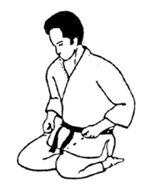

MIND CLEARING EXERCISES
1. Imagine your mind as a theater stage as you sit in a bath or in
front of a wall.
2. Concentrate on an object on the wall, gradually narrowing your focus
with half-closed eyes. Then imagine the object until it fills your
entire line of vision. In three to five minutes, your attention will
intensify. Try to slow down your breathing rate to quiet, short
breaths. Exhale slowly to the count of ten, then inhale with the
same count, bringing the air down into the diaphragm as if you were
pushing it down two inches below your navel. Concentrate on a branch
of a bush or tree. Focus on one leaf, but be aware of the other
leaves and branches. This exercise will help you in a combat
situation to concentrate on one adversary but be aware of all the
other adversaries.
3. Imagine that your mind is calm like the water in a pool reflecting
the sky above or the moon seeing over all. If your mind is
disturbed, the water becomes rippled and the moon becomes darkened.
In a combat situation you certainly want to have a mind calm enough
to see the total situation clearly and reflect only reality to your
response mechanisms.
KI TESTS
To see if you are making progress in developing control of your KI, you might try closing your eyes, relaxing your body and asking someone to lift you while you imagine that your weight is sinking into the floor, anchoring you to the floor with tons of energy. If you have done the work (20 to 30 minutes a day over a period of time), chances are the person won't be able to pick you up because your relaxed body has become like a heavy water barrel with the life force, or energy (KI) flowing into it. If your mental development is off balance, even slightly, it will be immediately obvious as you get moved.
You can call this super energy (KI) “faith,” “positive thinking,” “will power” --the power is there within you. If you can concentrate your mind on a small area, the physical force is increased two to five times the ordinary force. In practicing the focusing of your energy, you will experience the feeling that what you are attempting to do is impossible. You must rebel against limited thinking. Through meditation, concentration, and abdominal breathing, you can learn to control your mind and direct it and, as a consequence, your body. In case you are attacked, you will be prepared against fear and the concern of winning. With a mind like an ever rolling ball, fully aware of the situation at all times, never freezing on the problem, you guard your mind from your opponent, and are in a much better position to handle the attack.

THE GROWTH PYRAMID
Definitions of terms used in growth pyramid:
- Over-all Confidence: Do you have respect for yourself? Do you assert your thoughts and ideas? Do you possess strong leadership qualities? Do you feel in harmony with yourself and your surroundings?
- Emotional Maturity: Do you control your emotions instead of being controlled by them? Do you have a well-balanced ego—are you able to enjoy the praise of others but are not dependent on it?
- Proper Attitude: Are you highly motivated to succeed? Are you willing to learn and train with patience? Do you have established goals?
- Mental Versatility: Can you look past martial arts and see into all aspects of life?
- Organization and Structure: Have you established the time and place to train and a schedule for training?
- Flexibility, Coordination, Rhythm and Timing: Do you feel a totally balanced interaction of mind and body motion?
- Endurance, Strength and Intensity: Are you capable of high levels of sustained output? Is your flow of effective power constant? Are you capable of an awesome emotional explosion?
- Speed of Motion and Reaction: Is your motion efficient so as to reach your target in the most direct manner? Is your response to threat immediate?
- Visual Clarity: Do you have the peripheral and direct vision that allows you to be sensitive to refined movement?
- Consistence: Do you maintain a constant effort to reach your goal as efficiently as possible?
- Applied Offensive and Defensive Skills: Do you posses the simple, efficient and practical techniques for any physical encounter?
- Knowledge and Creativity: Can you produce fresh or original ideas and design new approaches to old information? Are you well-versed in all aspects of your chosen area of training?
- Success: Have you achieved the total integration of all the previous areas defined?

REQUIREMENTS FOR PROMOTION TO 3RD DEGREE BROWN BELT

1. Explain the medical implication of a Karate blow to the bridge of
the nose and to the ribs
2. Two man attack - show the proper self-defense techniques when being
attacked by two people
3. Name all vital points of the body
4. Name 20 pressure points of the body
5. Knowledge of various other martial arts and its history
6. Write a one page report on KUMITE
7. Perform Chinto Kata satisfactory and explanation of each movement
8. Knowledge of defensive and offensive kumite techniques
9. Four months of study as a PURPLE BELT or at least 32 class
attendance

ROPE JUMPING

Because of the endurance and muscular coordination benefits, rope jumping should be a part of every athlete’s training program. Although there are hundreds of ways to jump rope, the sequence shown below is the basic method for the “pepper rhythm.”

To start the rope moving smoothly, begin with your arms forward (A). From this point, swing your arms downward and to the rear, and then continue the circular movement upward (B). As a result, your hands move in large circles with the chief points of rotation at the shoulder joints.

After the rope is moving rapidly (A through D) your arms should actually move very little. Most of the turning force for subsequent rope swings should be developed by wrist action. Note that the hands remain close to the hips (D and E). Some movement of the forearms is allowed but the main action is in the wrists.

From (F) the rope continues to (D) and the cycle is repeated for as long as you desire. You should land on the balls of your feet and spring upward in a rebounding action. To achieve the correct rhythm most of the action must occur at the ankle joints, not at the knee joints.

Basic rope jumping (pepper rhythm)

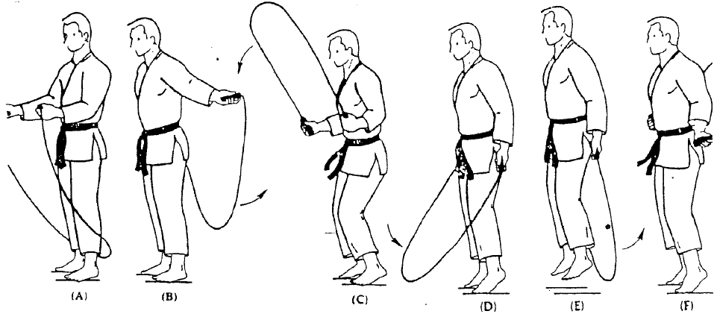
THE FOLLOWING SAYINGS MEAN MORE TO YOU THAN JUST WORDS

PROVERBS

When your hand goes out, withdraw your anger, when your anger goes out, withdraw your hand.

We shall not cease from exploration. And the end of all our exploring will be to arrive where we started, and know the place for the first time.

The martial arts is a lifetime study. It is not a matter of months or years. It is for life.

Don’t follow the ancient masters. Follow what the masters followed.

The river changes never, yet the water changes always.

Patience and hard work is really all it takes to be a good karateka.

The real value of acquiring an ability, especially Karate, is always trying to do better than you did yesterday and do better than that tomorrow. If you face this challenge, you will discover and appreciate everything that the art of Karate has to offer.

Equally important in Karate is the moral and spiritual aspects of Karate, without which Karate becomes a weapon to destroy rather than a means for self-defense and self-improvement.

Karate is a miniature of life itself. It involves all the elements of living. Emotion, violence, discipline of the mind, physical development, coordination – a distinct philosophy. What you learn in Karate, you can apply in life.

He who knows much about others may be learned, but he who understands himself is more intelligent.

He who controls others may be powerful, but he who has mastered himself is mightier still.

When you see a good man, seek to emulate him. When you see a bad man, examine your own heart.

The knowing do not talk, the talking do not know.

A fat belly cannot believe that such a thing a hunger exists.

Real living is living for others.

If every man would help his neighbor, no man would be without help.
Yesterday’s dreams are often tomorrow’s realities.

You can acquire a lot in life, if you are prepared to give up a lot to get it.

A wise man can learn more from a foolish question than a fool can learn from a wise answer.

A goal is not always meant to be reached, it often serves simply as something to aim at.

A man is born to achieve great things if he has the strength in conquering himself.

It’s not what you give, it’s the way you give it.

One great cause of failure is lack of concentration.

Showing off is the fool’s idea of glory.

If you spend too much time thinking about a thing, you’ll never get it done – do it.

Knowledge will give you power, but character respect.

Self-education makes great men.

Mistakes are always forgivable, if one has the courage to admit them.

If you think a thing is impossible, you’ll make it impossible.

If you make an ass of yourself, there’ll always be someone ready to ride you.

If you love life, don’t waste time, for time is what life is made of.

He who is aware of his own weakness will remain a master of himself in any situation; only a true weakling is capable of true courage.

REQUIREMENTS FOR PROMOTION TO 2ND DEGREE BROWN BELT

- Explanation of the GROWTH PYRAMID
- Explanation on how to bandage an ankle
- Explain the medical implications of a Karate blow to the Solar Plexus
- Name ALL the pressure points of the body
- SHOCK – definition, causes and symptoms; along with its treatment and
first aid
- A two-page report on the Karate Dojo
- Perform Kusanku Kata satisfactory and explanation of each movement
- Four months of study as a San Kyu or at least 32 class attendance

M. Figure-of-eight bandage for the ankle
Anchor the bandage on the instep and take two or three additional turns around the instep and foot. Carry the bandage diagonally upward across the front of the foot, then around the ankle (Figs. 1 & 2) and diagonally downward across the front of the foot and across under the arch. Make several of these figure-of-eight turns, each turn overlapping the previous one by about two-thirds the width of the bandage (Fig. 3). Occasionally, use an extra turn around the ankle. Complete by tying off (Fig. 4).

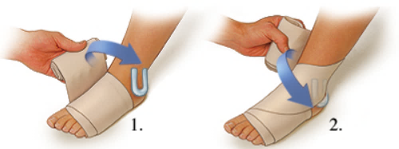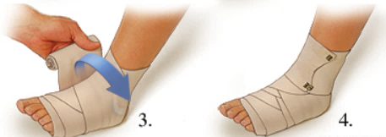
STRIKING THE SOLAR PLEXUS
WEAPON: Straight Punch TARGET: Solar Plexus
MEDICAL IMPLICATIONS:
If the punch is directed toward the right side of the opponent's body, the liver and gall bladder will be damaged. If it is in the center of the solar plexus, the duodenum and pancreas will be thrust against the front of the lumbar spine. The abdominal aorta (huge vein) follows the lumbar spine vertically and is very snug against the front side of the vertebra. If the punch was strong enough to injure the vein, shock (extreme loss of blood) and death would follow almost immediately. The stomach (and some reports claim the spleen) will be involved when the blow is to the left side of the solar plexus. The level, angle and strength of the punch will determine how many of these organs will be damaged.
I. A DEEP FISSURE IN THE LIVER may very well be fatal. Peritonitis is the name given to free floating blood and/or bile in the peritoneal cavity (body cavity). Hiccupping from blood or bile irritating the diaphragm and an increasing tenderness and pain in the abdomen will continue until surgery of the abdomen corrects the symptoms which may very easily evolve into death.
II. THE GALL BLADDER WOULD BE TORN with gastric acids and digestive juices being spilled into the body cavity. (Prior to a meal, the gall bladder fills with proper digestive juices for digestion of the meal and stores the juices until food is induced. The gall bladder would burst rather easily if enough pressure was exerted upon it during the predigestion period). The juices would immediately start to digest the internal organs they came in contact with, and only surgery would prevent death.
III. RUPTURE OF THE STOMACH with the spilling of its contents and blood into the body cavity would again result in peritonitis. Days of intestinal disturbances, gastric disorders and vomiting, shock, and eventual death will occur.
IV. A compression injury of the DUODENUM against the lumbar spine will progress the same as III above.
V. AN INJURED PANCREAS may result if the punch were well timed (when the opponent was inhaling) and the solar plexus is relaxed and easily penetrated. The pancreas might also be compressed, along with the duodenum, against the lumbar spine producing a split surface of the organ. Respiratory paralysis (spasm of the abdominal and intercostal rib muscles, which inhibits normal movements of the diaphragm in breathing) can produce unconsciousness, shock and death.
VI. PARTIAL COLLAPSE OF THE LUNG due to a minute plural tear from the percussive shock (jarring) present in the chest cavity at the moment of impact, will result in shallow breathing and great pain during respiration.
VII. SHOCK is a term used in internal injuries to describe the extreme loss of blood and bile into the body cavity. Shock may be immediately fatal or be latent (48 hours later) until abdominal splinting occurs. Abdominal splinting means that when the cavity fills with blood, it will be evident because of a growing tenderness and increasing rigidity of the abdomen, with the rupture of the stomach or duodenum. Death is the common result of shock, because usually by the time the injured person arrives at the hospital he has lapsed into unconsciousness from lack of blood and cannot tell a doctor his symptoms.
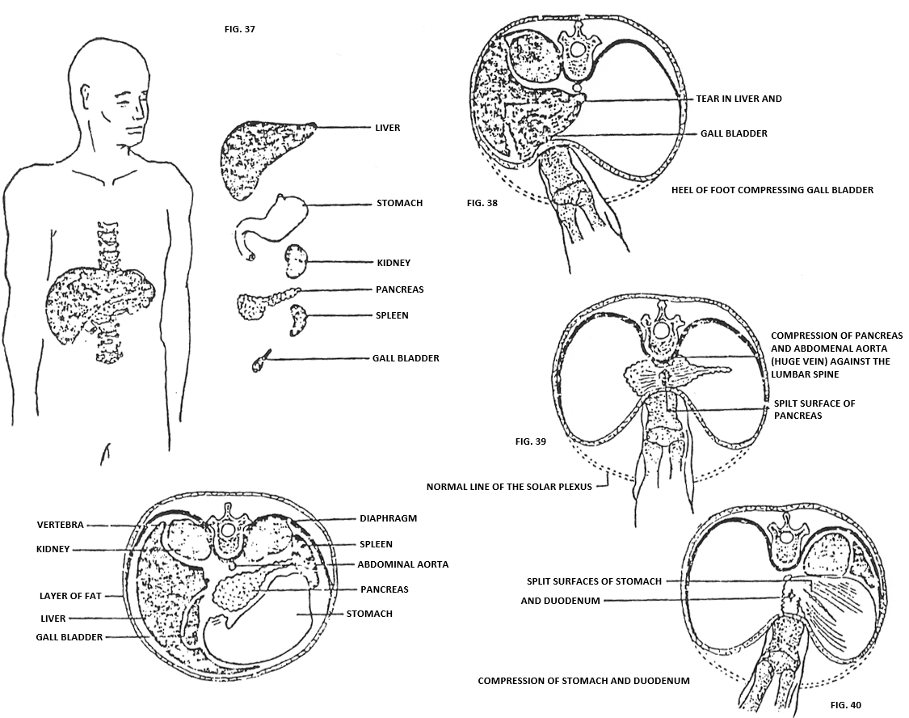

STRIKING THE EYE
WEAPON: Finger Tips TARGET: Eye
MEDICAL IMPLICATIONS:
I. The possible results are so many in this area, that we will concern ourselves with only the more obvious trauma.
RUPTURE OF THE EYE BULB WITH PROTRUSION OF THE WATERY AND GELATINOUS LIKE CONTENTS will result when the bulb is no longer able to withstand the direct pressure piercing it.
TEMPORARY TO PERMANENT BLINDNESS (Probably permanent) is the common result. Tremendous shocking pain will prevail in one or both eyes. An uncontrollable watering of the eyes will always be functional whenever a foreign object enters or touches the eye, which naturally produces temporary blurred vision in the uninjured eye.
II. A TORN EYELID (usually the top one) is the effect of a sharp fingernail piercing an eyelid that has blinked at the last instant before the nail has struck. Infection following trauma of this kind is the usual aftermath because of the small debris (dirt, germs, hair, etc.) that enters the eye with the finger and nail. Sometimes infection can be a more serious complication than the blow itself.
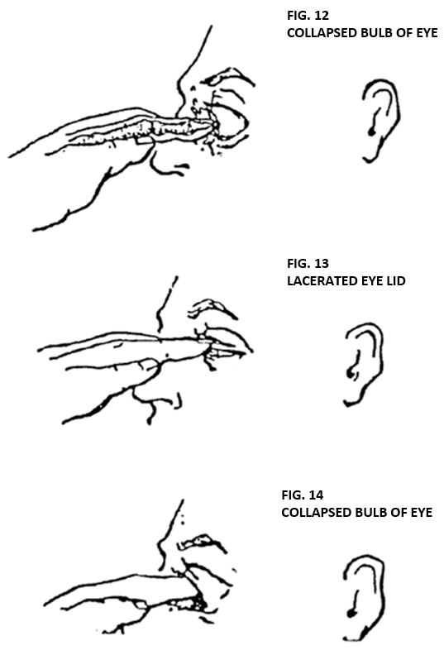

STRIKING THE SIDE OF THE RIB CAGE
WEAPON: Side kick with blade of the foot TARGET: Side of ribs
MEDICAL IMPLICATIONS:
I. A green stick fracture of the ribs will cause only pain in breaching, but a complete break in the rib, with protruding ends, will tear the lung's pleura (membrane sac covering the lungs) and puncture the lung, resulting in a COLLAPSED LUNG. Blood in the lung cavity (hemothorax) will be present until it is removed. Shortness of breath and muscle spasms of the chest and rib cage, with severe pain while breathing will predominate. If the lung collapses all the way, death is sure to follow. A lung may be collapsed from the violent jarring produced by the kick, without the presence of a fractured rib. When the pleura tear is very small, it will usually seal itself soon without any great after effects.
The great danger involved with a completely collapsed lung (besides air starvation) is an uncontrollable spasm of the heart, which is caused by the pressure difference when the lung collapses. The heart is held in place (partially) by the lungs on either side, and the heart's suspensory ligaments. When there is no pressure on one side to help hold the heart in place, the lung on the other side will pull the heart toward it (heart shift), resulting in a severe muscle spasm of the heart and usually either a quick or lingering death. Intercostal muscles spasms (the muscles between the ribs) with loss of breath would be the minimal damage. A complication of the blow would be puncture of the diaphragm.

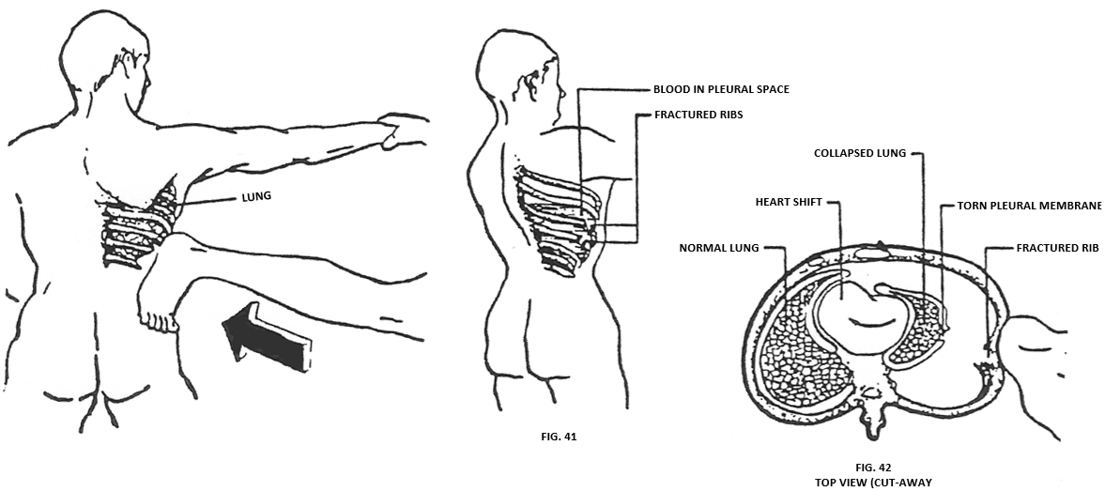

STRIKING THE BRIDGE OF THE NOSE
WEAPON: Uppercut TARGET: Nasal bone
MEDICAL IMPLICATIONS:
I. A COMPOUND FRACTURE AND/OR DISLOCATION OF THE NASAL BONE AND SEPTUM (dividing part of the nostrils) are consequence of all four knuckles raking across the upper part of the nose. Needless to say, there will be massive hemorrhage because of the many blood vessels in this area. Shock and pain may render your opponent unconscious. Temporary blindness may be a result of the extreme watering of the eyes because of the stimulated pain receptors in the nasal region. We must realize that many times the blow may not be a death-dealing one, but the accidental consequences may end in death. In this case we are talking about unconsciousness which invariably occurs before the opponent hits the ground. The effect is a grave one because the head is relaxed when it strikes the ground and may end in a serious concussion or skull fracture if the surface is fairly solid. Death may also ensue because of the huge amount of blood clogging the trachea (wind pipe) during unconsciousness.
II. FRACTURE INTO THE ORBITAL SOCKET (eye socket) with possible cerebral involvement may be a complication of the blow. If the fracture line has continued into the brain casing (cribriform plate of the ethmoid bone), a slight tear in the dura will release small amounts of cerebrospinal fluid. The fluid will travel through the sinuses and finally exit through the nostrils or be swallowed. Cerebrospinal fluid (clear fluid that circulates in the closed cavity of the brain and spinal cord) is sometimes mistaken for a normal secretion for quite some time, until severe headaches motivate the individual to seek medical advice.
When bone (or for that matter any part of the body) is struck, the force of the blow is transferred from the weapon to the target in the form of oscillator vibrations. In the case of bone the oscillations follow the path of least resistance. The oscillations are further apart in wide or thick bone and closer together in thin or narrow bone. As oscillations narrow the vibrations become more violent and cause a fracture through the weakest portion of bone.
The olfactory nerves (nerves of smell) are spread throughout the roof of the nasal section (cribriform plate of the ethmoid bone) and may become torn or levered from the fractured bone. A dulling of the sense of smell will occur.
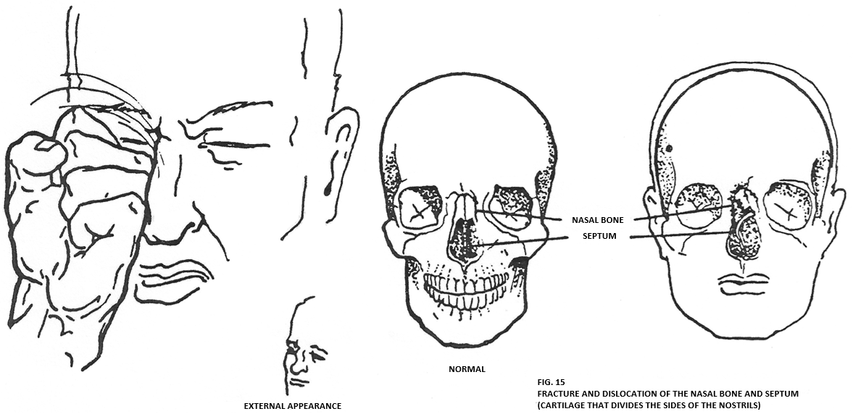
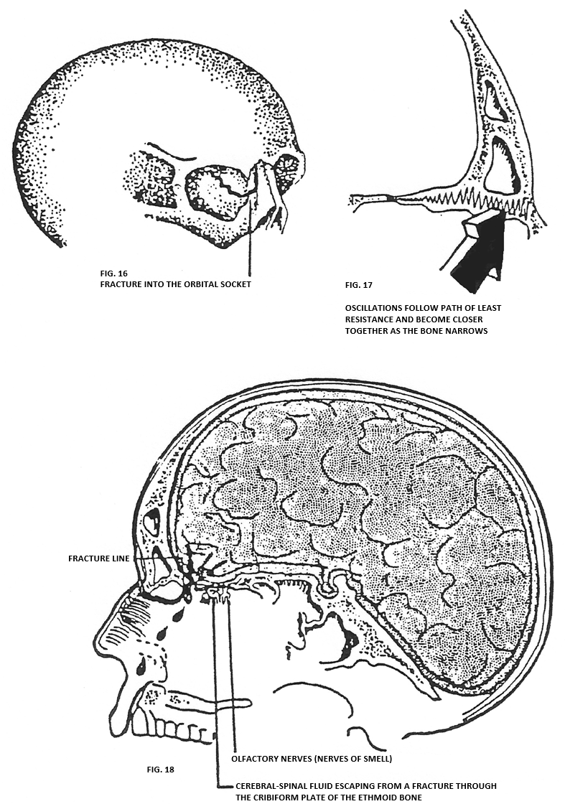
SHOCK
DEFINITION
Shock is a condition resulting from a depressed state of many vital body functions, a depression that could threaten life even though the victim’s injuries would not otherwise be fatal.
Injury-related shock, commonly referred to as traumatic shock, is decidedly different from electrical shock, insulin shock, and other special forms of shock.
CAUSES
A.Shock may be caused by severe injuries of all types; hemorrhage, or loss
of body fluids other than blood (as in prolonged vomiting, dysentery, or
burns); infection; heart attack or stroke; or poisoning by chemicals,
gases, alcohol or drugs. Shock also results from lack of oxygen, caused
by obstruction of air passages or injury to the respiratory system.
B.The degree is shock is increased by abnormal changes in body temperature
and by poor resistance of the victim to stress.
C.Shock is aggravated by pain, rough handling and delay in treatment.
SIGNS AND SYMPTOMS
A.EARLY STAGES
In the early stages of shock, the body compensates for a decreased blood
flow to the tissues by constricting the blood vessels in the skin, soft
tissues and skeletal muscles. The following signs may develop as a
result:
1.The skin is pale (or bluish) and cold to the touch. In the care of
victims with dark skin, it may be necessary to rely primarily on the
color of the mucous membranes on the inside of the mouth or under the
eyelids or of the nailbeds.
2.The skin may be moist and clammy if perspiration has occurred.
3.The victim is weak.
4.The pulse is usually quite rapid (over 100) and often too faint to be
felt at the wrist radial artery but is perceptible in the carotid
artery at the side of the neck or in the femoral artery at the groin.
5.The rate of breathing is usually increased; it may be shallow,
possibly deep and irregular.
6.If there has been injury to the chest or abdomen, breathing will
almost certainly be shallow, because of the pain involved in breathing
deeply.
7.A victim in shock from hemorrhage may be restless and anxious (early
signs of oxygen lack), thrashing about and complaining of severe
thirst.
8.The victim may vomit or retch from nausea.
B.LATE STAGES
If the victim's condition deteriorates, the following additional signs may
be noted:
1.The victim becomes apathetic and relatively unresponsive.
2.The victim’s eyes are sunken, with a vacant expression, and his
pupils may be widely dilated (Fig.21)
3.Some of the blood vessels in the skin may be congested, producing
a mottled appearance, which indicates the victim’s blood pressure
has fallen to a very low level.
4.If untreated, the victim eventually loses consciousness, his body
temperature falls and he may die.
TREATMENT OBJECTIVES
A.To improve circulation of the body
B.To ensure an adequate supply of oxygen
C.To maintain normal body temperature
FIRST AID
Give urgently necessary first aid immediately to eliminate the causes of shock, such as stoppage of breathing, hemorrhaging or severe pain.
A.Steps for preventing shock and for giving first aid.
1.Keep the victim lying down.
2.Cover him only enough to keep him from losing body heat.
3.Get medical help as soon as possible.
B.Body position
1.The position for a victim must be based on his injuries. Generally,
the most satisfactory position for the injured person will be lying
down to improve the circulation of blood.
2.If injuries of the neck or lower spine are suspected, do not move
the victim until he is properly prepared for transportation, unless
it is necessary to protect him from further injury or to provide
urgent first aid care.
3.A victim with severe wounds of the lower part of the face and jaw or
who is unconscious, should be placed on his side to allow drainage
of fluids and to avoid blockage of the airway by vomitus and blood
(Fig.22). Extreme care must be taken to ensure an open airway and to
prevent asphyxia. When there is no danger of aspiration of fluids, a
victim who is having difficulty breathing, may be placed on his back
with his head and shoulders raised (Fig.23).
4.A person with a head injury may be kept flat or propped up, but his
head must not be lower than the rest of his body.
5.If in doubt concerning the proper position of the victim based on
injuries sustained, keep him lying flat.
6.Vicitms in shock may improve if the feet (or foot of the stretcher)
are raised from 8 to 12 inches (Fig.24). If the victim has increased
difficulty in breathing or experiencing additional pain after his
feet are raised, lower the feet again.
C. Regulating body temperature.
Keep the victim warm enough to avoid or overcome chilling. If the
victim is exposed to cold or dampness, blankets or additional clothing
should be placed over and under him to prevent chilling (Fig.25). No
attempt should be made to add extra heat, because raising the surface
temperature of the body is harmful.
D.Administering fluids.
l.Giving fluids by mouth has value in shock, but fluids should only be
given when medical help is not available within a reasonable time.
Fluids should not be given, however, when victims are unconscious, are
vomiting or are likely to vomit, or are having convulsions, since
victims in such states may aspirate fluids into the lungs.
2.Do not give fluids when a victim is likely to require surgery or
general anesthetic, or when he appears to have a brain or abdominal
injury.
3.Fluids may be given by mouth only if medical care is delayed for an
hour or more and no contraindications exist. Water that is neither hot
nor cold--preferably a salt-soda solution (containing 1 level
teaspoonful of salt and 1/2 level teaspoonful of baking soda to each
quart of water) should be given as follows:
a. An adult victim should be given about 4 ounces (1/2 glass) every 15
minutes.
b. Approximately 2 ounces should be given to children aged 1 to 12,
and l ounce to infants of 1 year or less.
c. Discontinue fluids if the victim becomes nauseated or vomits.

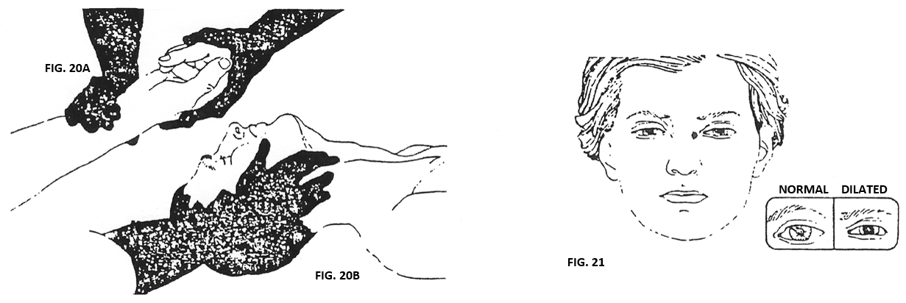

TREATMENT FOR SHOCK CONTINUED

REQUIREMENTS FOR PROMOTION TO 1ST DEGREE BROWN BELT

- Write a three-page report on the history and tradition of Karate
- What is the RICE program
- History of Sai
- History of Bo
- Must be a willing and capable assistant in teaching of Isshin-ryū Karate classes
- Four months of study as a 2nd degree Brown Belt or 32 class attendance
- Perform Sunsu and Sanchin satisfactory and explanation of each movement

COMMON INJURIES
AND
WHAT TO DO ABOUT THEM (Katsu)
WHEN TO SEE A DOCTOR
All traumatic joints injuries should be examined by a physician because these injuries have the potential of becoming permanent and debilitating if proper treatment is not administered.
Any injury accompanied by severe pain. Pain is nature’s way of talking to you and when it speaks loudly, you had better listen.
Any pain in a joint or bone that persists for more than two weeks. These tissues are the ones in which the most serious injuries occur.
Any injury that doesn’t heal in three weeks. All injuries that don’t heal should be checked for a structural abnormality that may have caused them. Sometimes an injury may not heal because you won’t rest it.
Any infection in or under the skin manifested by pus, red streaks, swollen lymph nodes or fever.
The immediate treatment for almost all athletic injuries is the same, whether you’ve pulled a muscle, strained a ligament, hurt a joint or broken a bone. It’s a four-part program that you can follow even if you will be seeking a physician’s advice and it is abbreviated R I C E:
REST: Rest is necessary because continued exercise could extend the
injury. Stop using the injured part the minute it is hurt.
ICE: Ice decreases the bleeding from injured blood vessels because
it causes them to contract. The more blood that collects in the
wound, the longer it takes to heal.
COMPRESSION: Compression limits swelling which, if uncontrolled,
could retard healing. Following trauma, blood and fluid from
the surrounding tissues leak into the damaged area and distend
the tissue. Swelling is sometimes useful since it brings
antibodies to kill germs, but if the skin is not broken,
antibodies are unnecessary and swelling only prolongs healing.
ELEVATION: Elevation of the injured part to above the level of the
heart uses the forces of gravity to help drain excess fluid.

Because swelling usually starts within seconds of an injury, start RICE as soon as possible. First place a towel over the injured area. Then apply an ice pack, ice chips or cubes over the towel. Do not apply ice directly to the skin as it can cause the skin to hurt.
For compression, wrap an elastic bandage firmly over the ice, around the injured part. Be careful not to wrap the area so tightly that you shut off the blood supply. The signs of a shut-off blood supply are numbness, cramping and pain. If any of these happens, unwrap the area immediately. Otherwise, leave the ice pack and bandage in place for thirty minutes. Next, to allow the skin to rewarm and the blood to recirculate, unwrap the area for fifteen minutes. Then rewrap the area. Repeat this procedure for three hours. If the area continues to swell or the pain increases, check immediately with a physician.
PULLED MUSCLES
Muscle pulls result when more tension is applied to a muscle than it can bear. As a general rule, the more severe the pain, the more extensive the injury. Usually muscle pulls occur when you try to exercise intensely at a time when one or more of the following factors predispose you to injury:
INSUFFICIENT WARM-UP: Your muscles are stiff and tight and therefore
susceptible to injury. Before playing a sport you should warm up
for at least ten minutes by performing that sport with slow,
easy movements and gradually increase the pace.
POOR FLEXIBILITY: Every time you exercise hard, your muscles are
slightly damaged. With healing, they shorten and, like a tight
violin string, are susceptible to tearing unless you have
restored flexibility by STRETCHING.
TRAUMA: Stepping into a hole or being hit by someone can cause
excess muscle stress and consequent injury.
LACK OF AN ADEQUATE ENDURANCE PROGRAM: Rhythmic endurance exercises
thicken the muscles, tendons and ligaments and make them more
resistant to injury. Every athlete should have a year-round
exercise for the muscles. KARATE IS A YEAR-ROUND PROGRAM.
MUSCLE CRAMPS
Muscle cramps are painful, they can last for just a few seconds or continue for several hours.
Any muscle can cramp. The cramp can be so mild that you will feel only a slight muscle twitch or so severe that it can break a bone.

Although cramps can occur during sleep, they usually occur during intense exercise. No athlete is immune to this common condition.
There are many causes:
Salt deficiency
Low levels of other minerals such as potassium or magnesium
An injury or strain on the muscles
An obstruction of the muscle’s blood supply by sustained muscular
contractions
Hyperventilating – breathing too fast when it is not necessary,
which prevents the body from using calcium
EAT MORE FRUITS AND VEGETABLES to replace potassium. Potassium is the
mineral that is lost in large amounts during hard exercise.
TREATMENT OF A CALF CRAMP
The treatment of a cramp is to stretch and squeeze the muscle. If it’s the calf, squeeze the muscle with one hand and stretch it by pushing the front part of the foot up with the other hand.

REQUIREMENTS FOR PROMOTION TO SHO DAN

- Perform Kusanku-Sai and Tokumine No Kun (Bo) satisfactorily and explanation of each movement
- Know the training manual from cover to cover
- The Isshin-ryū Board of Examiners will determine if you are eligible for SHO-DAN rank – remember you are going for a Black Belt, we must see Black Belt materials
- Length of time – when all specifications are met
- Present a report explaining what the study of Isshin-ryū truly means to you.
- Must have teaching ability, showing great leadership ability and understanding of the students’ needs

STUDENT CREED
I intend to develop myself in a positive manner and avoid anything that would reduce my mental growth or physical health.
I intend to develop self-discipline, in order to bring out the best in myself and others.
I intend to use what I learn in class constructively and defensively, to help myself and others and never be abusive or offensive.

ISSHIN-RYŪ KARATE-DO & SELF-DEFENSE DOJO PATCH

Round – Symbolizes the study of Karate (continuous)
Heart – Represents the one-heart way of Isshin-ryū Karate-Do
Triangle – Represents the Growth Pyramid
3 Stars – Physical, Mental, Spiritual
Fist – Isshin-ryū fist
Kanji – Isshin-ryū Karate-Do (One Heart Way Empty Hand Style)
Blue – Represents Fidelity/Honor
Red – Represents Courage/Strength
White – Purity

THE 15 PRINCIPLES
- A good attitude is the most important characteristic of a karateka
- Leave your ego and your shoes at the front door.
- Those who would be first, must first learn how to be last.
- The mettle in one’s character must be stronger than the metal in one’s sword.
- Knowledge will give you power, but character will give you respect.
- The knowing do not talk; the talking do not know.
- Honor your mother and father; love your neighbors; pray for your enemies.
- If you think a thing is impossible, you will make it impossible.
- Persistence is the essence of success.
- Ten times you get knocked down--eleven times you get up.
- Can’t is a four letter word.
- Showing off is the fool’s idea of glory.
- To err is human. To forgive is divine.
- When your hand goes out, withdraw your anger; when you anger goes out, withdraw your hand.
- Isshin-ryū Karate: Direct force, swiftly applied.

PROMOTION REPORTS

White Belt to Yellow Belt: “What Karate has done for me” (minimum one
page).
Yellow Belt to Orange Belt: “Tatsuo Shimabuku” (minimum one page).
Orange Belt to Blue Belt: “The belt ranking system” (minimum one page).
Blue Belt to Green Belt: “Basics” (minimum one page).
Green Belt to Purple Belt: “Kata” (minimum one page).
Purple Belt to 3rd Brown: “Kumite” (minimum one page).
3rd Brown to 2nd Brown: “The Karate dojo” (minimum two pages).

2nd Brown to 1st Brown: “History and tradition of Karate” (minimum two
pages).
1st Brown to 1st Black: Three (3) five page reports (Sensei will advise of
available topics).

Remember, your goal is to become a Blackbelt! Train hard and study hard! Read!

PROMOTION KATA REQUIREMENTS

White Belt to White Belt 1 Stripe: All Basic Hand and Foot Techniques
White Belt 1 Stripe to White Belt 2 Stripes: Uke Kata
White Belt 2 Stripes to Yellow Belt: Seisan Kata
Yellow Belt to Orange Belt: Seiuchin Kata
Orange Belt to Blue Belt: Dachi Kata, Naihanchi Kata and Batta
Wakai No Bo Kata
Blue Belt to Green Belt: Wansu Kata, Tokumine No Kun Kata
and Sai Basics
Green Belt to Purple Belt: Chinto Kata and Kyan No Sai
Purple Belt to 3rd Brown: Kusanku Kata and Kusanku No Sai
3rd Brown to 2nd Brown: Sunsu Kata

2nd Brown to 1st Brown: Sanchin Kata

1st Brown to 1st Black: All previous requirements
1st Black to 2nd Black: Urashi No Kun Kata and Chatan Yara No
Sai
2nd Black to 3rd Black: Shishi No Kun Kata and Hamahiga No
Tuifa Kata

Remember, your goal is to become a Blackbelt! Train hard and study hard! Read!

ISSHIN-RYŪ KATA FOCUSES

SEISAN: Balances left and right.
SEIUCHIN: Develops grounding.
NAIHANCHI: Develops inner strength and
in-close techniques
WANSU: Develops rhythm and
timing.
CHINTO: Develops balance.
KUSANKU: Develops strategy.
SUNSU: Making sure you know the
rest.
SANCHIN: Harnesses ki.

ISSHIN-RYŪ KARATE-DO KATA LINEAGE
UKE KATA
HARRILL, Sherman
Isshin-ryū
(1941-2002)
CROWTHER, John
Isshin-ryū
(1945- )

SEISAN KATA
WONG, Chung-Yoh
Kempo
(Chatan) YARA
Kempo
(b.1725; c.1750)
(Pēchin) TAKAHARA
Okinawa-te
(1688-1760)
(Karate) SAKUGAWA
To-de
(1733-1815)
(Bushi) MATSUMURA, Sokun
Shuri-te
(1797-1889)
(Migwa) KYAN, Chōtoku
Shorin-ryū
Shobayashi-ryū
(1870-1945)
(Sunsu) (Tatsuo) SHIMABUKU, Shinkichi
Migwa-te
Isshin-ryū
(1908-1975)
NAGLE, Donald
Isshin-ryū
(1938-1999)
LIZOTTE, Lewis
Isshin-ryū
(1935-2018)
HOLUBECKI, Chester
Isshin-ryū
(1944- )
CROWTHER, John
Isshin-ryū
(1945- )

SEIUCHIN KATA
(Ryū Ryūko) WOO, Lu Chin
Shorin-ji; Pa kua chang
(c.1870)
(Macha) (Kensei) HIGASHIONNA, Kanryo
Naha-te
(1851-1915)
MIYAGI, Chojun
Goju-ryū
(1888-1953)
(Sunsu) (Tatsuo) SHIMABUKU, Shinkichi
Migwa-te
Isshin-ryū
(1908-1975)
NAGLE, Donald
Isshin-ryū
(1938-1999)
LIZOTTE, Lewis
Isshin-ryū
(1935-2018)
HOLUBECKI, Chester
Isshin-ryū
(1944- )
CROWTHER, John
Isshin-ryū
(1945- )

DACHI KATA
HARRILL, Sherman
Isshin-ryū
(1941-2002)
CROWTHER, John
Isshin-ryū
(1945- )

NAIHANCHI KATA
WONG, Chung-Yoh
Kempo
(Chatan) YARA
Kempo
(b.1725; c.1750)
(Pēchin) TAKAHARA
Okinawa-te
(1688-1760)
(Karate) SAKUGAWA
To-de
(1733-1815)
(Bushi) MATSUMURA, Sokun
Shuri-te
(1797-1889)
ITOSU, Yasutsune
Shuri-te
(1830-1915)
(Migwa) KYAN, Chōtoku (Saru) MOTOBU, Choki
Shorin-ryū Shorin-ryū
Shobayashi-ryū (1871-1944)
(1870-1945)
(Sunsu) (Tatsuo) SHIMABUKU, Shinkichi
Migwa-te
Isshin-ryū
(1908-1975)
NAGLE, Donald
Isshin-ryū
(1938-1999)
LIZOTTE, Lewis
Isshin-ryū
(1935-2018)
HOLUBECKI, Chester
Isshin-ryū
(1944- )
CROWTHER, John
Isshin-ryū
(1945- )
WANSU KATA
WONG, Chung-Yoh
Kempo
(Chatan) YARA
Kempo
(b.1725; c.1750)
(Pēchin) TAKAHARA
Okinawa-te
(1688-1760)
(Karate) SAKUGAWA
To-de
(1733-1815)
(Bushi) MATSUMURA, Sokun (Torisu) MAKABE, Chokun
Shuri-te To-de
(1797-1889) (b.1785)
MATSUMORA, Kosaku
Tomari-te
(1829-1898)
(Migwa) KYAN, Chōtoku (Saru) MOTOBU, Choki
Shorin-ryū Shorin-ryū
Shobayashi-ryū (1871-1944)
(1870-1945)
(Sunsu) (Tatsuo) SHIMABUKU, Shinkichi
Migwa-te
Isshin-ryū
(1908-1975)
NAGLE, Donald
Isshin-ryū
(1938-1999)
LIZOTTE, Lewis
Isshin-ryū
(1935-2018)
HOLUBECKI, Chester
Isshin-ryū
(1944- )
CROWTHER, John
Isshin-ryū
(1945- )
CHINTO KATA
CHINTO
Chuan fa (Kempo)
(Macha) (Kensei) HIGASHIONNA, Kanryo
Naha-te
(1851-1915)
(Bushi) MATSUMURA, Sokun
Shuri-te
(1797-1889)
(Migwa) KYAN, Chōtoku
Shorin-ryū
Shobayashi-ryū
(1870-1945)
(Sunsu) (Tatsuo) SHIMABUKU, Shinkichi
Migwa-te
Isshin-ryū
(1908-1975)
NAGLE, Donald
Isshin-ryū
(1938-1999)
LIZOTTE, Lewis
Isshin-ryū
(1935-2018)
HOLUBECKI, Chester
Isshin-ryū
(1944- )
CROWTHER, John
Isshin-ryū
(1945- )

KUSANKU KATA
KUSANKU
Chuan fa (Kempo)
(c.1761)
(Karate) SAKUGAWA
To-de
(1733-1815)
(Bushi) MATSUMURA, Sokun
Shuri-te
(1797-1889)
(Migwa) KYAN, Chōtoku
Shorin-ryū
Shobayashi-ryū
(1870-1945)
(Sunsu) (Tatsuo) SHIMABUKU, Shinkichi
Migwa-te
Isshin-ryū
(1908-1975)
NAGLE, Donald
Isshin-ryū
(1938-1999)
LIZOTTE, Lewis
Isshin-ryū
(1935-2018)
HOLUBECKI, Chester
Isshin-ryū
(1944- )
CROWTHER, John
Isshin-ryū
(1945- )

SUNSU KATA
(Sunsu) (Tatsuo) SHIMABUKU, Shinkichi
Migwa-te
Isshin-ryū
(1908-1975)
NAGLE, Donald
Isshin-ryū
(1938-1999)
LIZOTTE, Lewis
Isshin-ryū
(1935-2018)
HOLUBECKI, Chester
Isshin-ryū
(1944- )
CROWTHER, John
Isshin-ryū
(1945- )

SANCHIN KATA
BODHIDHARMA
a/k/a Da Mo and Daruma Daishi
(c.520)
SHAOLIN MONKS
(Ryū Ryūko) WOO, Lu Chin
Shorin-ji; Pa kua chang
(c.1870)
(Macha) (Kensei) HIGASHIONNA, Kanryo
Naha-te
(1851-1915)
MIYAGI, Chojun
Goju-ryū
(1888-1953)
(Sunsu) (Tatsuo) SHIMABUKU, Shinkichi
Migwa-te
Isshin-ryū
(1908-1975)
NAGLE, Donald
Isshin-ryū
(1938-1999)
LIZOTTE, Lewis
Isshin-ryū
(1935-2018)
HOLUBECKI, Chester
Isshin-ryū
(1944- )
CROWTHER, John
Isshin-ryū
(1945- )

BATTA WAKAI NO BO KATA
CROWTHER, John
Isshin-ryū
(1945- )

TOKUMINE NO KUN KATA
(Pēchin) TOKUMINE
Bojutsu
(19th Century)
KEDAHANA, Gisa
Bojutsu
(1851-1915)
(Migwa) KYAN, Chōtoku
Shorin-ryū
Shobayashi-ryū
(1870-1945)
(Sunsu) (Tatsuo) SHIMABUKU, Shinkichi
Migwa-te
Isshin-ryū
(1908-1975)
NAGLE, Donald
Isshin-ryū
(1938-1999)
LIZOTTE, Lewis
Isshin-ryū
(1935-2018)
HOLUBECKI, Chester
Isshin-ryū
(1944- )
CROWTHER, John
Isshin-ryū
(1945- )

URASHI NO KUN KATA
SHINKEN, Taira
Kobudō
(1897-1970)
(Sunsu) (Tatsuo) SHIMABUKU, Shinkichi
Migwa-te
Isshin-ryū
(1908-1975)
NAGLE, Donald
Isshin-ryū
(1938-1999)
LIZOTTE, Lewis
Isshin-ryū
(1935-2018)
HOLUBECKI, Chester
Isshin-ryū
(1944- )
CROWTHER, John
Isshin-ryū
(1945- )

SHISHI NO KUN KATA
KENWA, Mabuni
Shitō-ryū
(1889-1952)
SHINKEN, Taira
Kobudō
(1897-1970)
(Sunsu) (Tatsuo) SHIMABUKU, Shinkichi
Migwa-te
Isshin-ryū
(1908-1975)
NAGLE, Donald
Isshin-ryū
(1938-1999)
LIZOTTE, Lewis
Isshin-ryū
(1935-2018)
HOLUBECKI, Chester
Isshin-ryū
(1944- )
CROWTHER, John
Isshin-ryū
(1945- )

KYAN NO SAI KATA
(Sunsu) (Tatsuo) SHIMABUKU, Shinkichi
Migwa-te
Isshin-ryū
(1908-1975)
NAGLE, Donald
Isshin-ryū
(1938-1999)
LIZOTTE, Lewis
Isshin-ryū
(1935-2018)
HOLUBECKI, Chester
Isshin-ryū
(1944- )
CROWTHER, John
Isshin-ryū
(1945- )

KUSANKU SAI KATA
(Sunsu) (Tatsuo) SHIMABUKU, Shinkichi
Migwa-te
Isshin-ryū
(1908-1975)
NAGLE, Donald
Isshin-ryū
(1938-1999)
LIZOTTE, Lewis
Isshin-ryū
(1935-2018)
HOLUBECKI, Chester
Isshin-ryū
(1944- )
CROWTHER, John
Isshin-ryū
(1945- )

CHATAN YARA NO SAI KATA
SHINKEN, Taira
Kobudō
(1897-1970)
(Sunsu) (Tatsuo) SHIMABUKU, Shinkichi
Migwa-te
Isshin-ryū
(1908-1975)
NAGLE, Donald
Isshin-ryū
(1938-1999)
LIZOTTE, Lewis
Isshin-ryū
(1935-2018)
HOLUBECKI, Chester
Isshin-ryū
(1944- )
CROWTHER, John
Isshin-ryū
(1945- )

HAMAHIGA NO TUIFA KATA
SHINKEN, Taira
Kobudō
(1897-1970)
(Sunsu) (Tatsuo) SHIMABUKU, Shinkichi
Migwa-te
Isshin-ryū
(1908-1975)
NAGLE, Donald
Isshin-ryū
(1938-1999)
LIZOTTE, Lewis
Isshin-ryū
(1935-2018)
HOLUBECKI, Chester
Isshin-ryū
(1944- )
CROWTHER, John
Isshin-ryū
(1945- )

